

**USER MANUAL SIGN-OFF**

**Authorization Memorandum**

This form is to sign-off completion of the Design Phase for **CAMPUS MANAGEMENT SOFTWARE AT WORLD SKILL CENTER (WSC).**

World Skill Centre (WSC) acknowledges receipt of the deliverables as part of the Design Phase through the submission of this document.

|  |  |
| --- | --- |
| **MODULE NAME** | **Admission** |
| **MODULE OWNER** |  |

**WSC AUTHORITY NAME AND SIGNATURE**

**SOUL AUTHORITY NAME AND SIGNATURE**

**Project Edulead**

**USER MANUAL**

**Student Lifecycle Management System Module-Admission**

**October 2023, Version 1.0**

**Sustainable Outreach and Universal Leadership Limited**

**Confidentiality**

This document is a strictly confidential communication to and solely for the use of the recipient and may not be reproduced or circulated without SOUL Ltd’s prior written consent. If you are not the intended recipient, you may not disclose or use the information in this documentation in any way

**Document Control History**

|  |  |  |  |  |
| --- | --- | --- | --- | --- |
| **Date** | **Version No.** | **Created By** | **Affected Sections** | **Reviewed By** |
|  |  |  |  |  |

**VERSION HISTORY**

|  |  |  |  |  |
| --- | --- | --- | --- | --- |
| **Date** | **Version No.** | **Created By** | **Updated Section** | **Updated By** |
| 13-10-2023 | Version 0.1 | Nehal Kumar |  |  |
|  |  |  |  |  |

**Content**

About this Manual 3

General Procedures 4

1. Department 14

2. Course Type 15

3. Courses 15

4. Semester 17

5. Modules 18

6. Topic 19

7. Class Rooms 20

8. Academic Year 21

9. Academic Term 21

10. Academic Events 22

11. Academic Calendar Template 23

12. Academic Calender 23

13. Documents 24

14. Documents Template 25

15. Eligibility Parameters 26

16. Student 26

17. Trainer 28

18. Student Category 29

19. Student Batch 30

20. Student Admission 30

21. Student Applicant 31

22. Course Enrollment 33

23. Module Enrollment 35

24. Fee Structure 36

25. Fee Schedule 37

26. Fee Category 38

27. Fees 39

28. Auto Reconciliation 40

29. Online Payment 42

30. Course Enrollment Tool 44

31. Student Feedback Form 45

### About this Manual

This User Manual acts as a reference for EduLead by describing its various concepts and abilities, and by leading the user through the basics of EduLead software. It also provides a detailed reference for all of the EduLead SLCM (Student Lifecycle Management) functionalities.

The User Manual describes all the processes and functionalities regarding various modules and its abilities to conduct the smooth transactions and integrations within the modules.

The software EduLead is an open-source, easy to use and customize, actively maintained, economical and well supported.

Throughout this manual it is assumed that the reader has a working knowledge of about Student Lifecycle Management and basic computer skills and knows how to:

* Use keyboard and mouse
* Use web browsers to access the EduLead website
* Locate, open and save data files.
* Edit, cut, paste and text.

The SLCM consists of 3 Modules mainly:

1. Admission
2. Academics
3. Examination

This User Manual consists of the **Admission Module** for End User reference and guidance. The manual describes how to use the Standard interface. As mentioned, it contains instructions that the users must follow during the operation and servicing of **EduLead**. Diverting from the workflow as mentioned in the user manual may result in errors and non-functioning of the software EduLead. It is advisable that the end users must abide by the instructions as mentioned in the user manual.

**General Procedures**

#### **General Procedures for a Save Screen**

**Create of New document**

1. Login in to the system
2. Go the required workspace, If user have more workspace

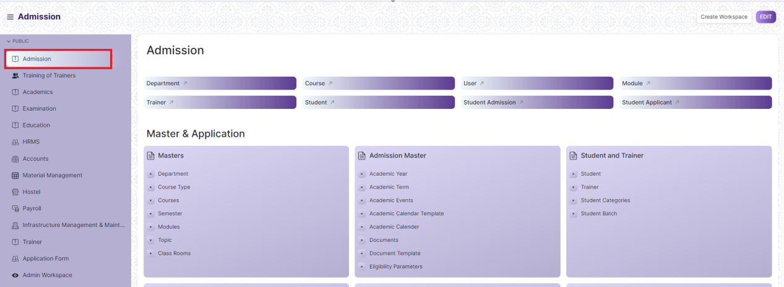

1. Go to the required screen.
2. Click on the ***“+Add Screen Name”*** button in the right corner of the screen.

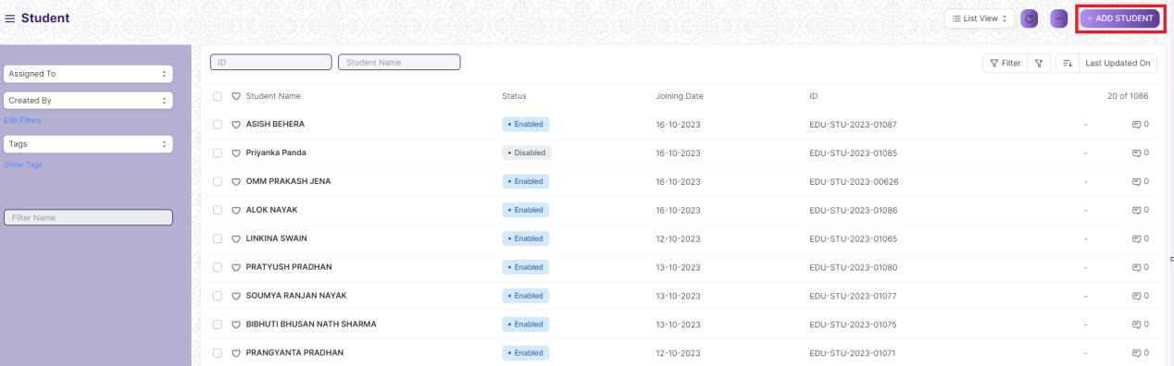

(Example : For addition in the new Student , click +Add Student button).

1. Enter the required data.
2. Click on “***Save”*.**
3. After saving , the record will be visible in the List View of the screen.

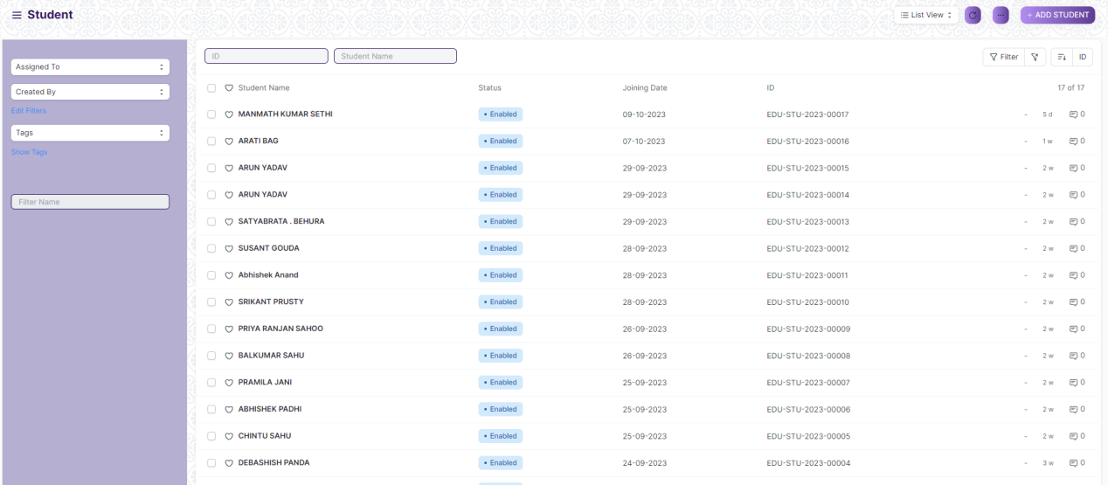

(Example : List view of saved Student)

**Note :** The process of creation can only be carried out by User who have necessary permission. Kindly refer to the Screen wise permission section in the document.

**View a Saved Document**

1. Log in to the system.
2. Go to the required workspace
3. Go to the required screen.
4. Click on the required document from the list view of the screen.

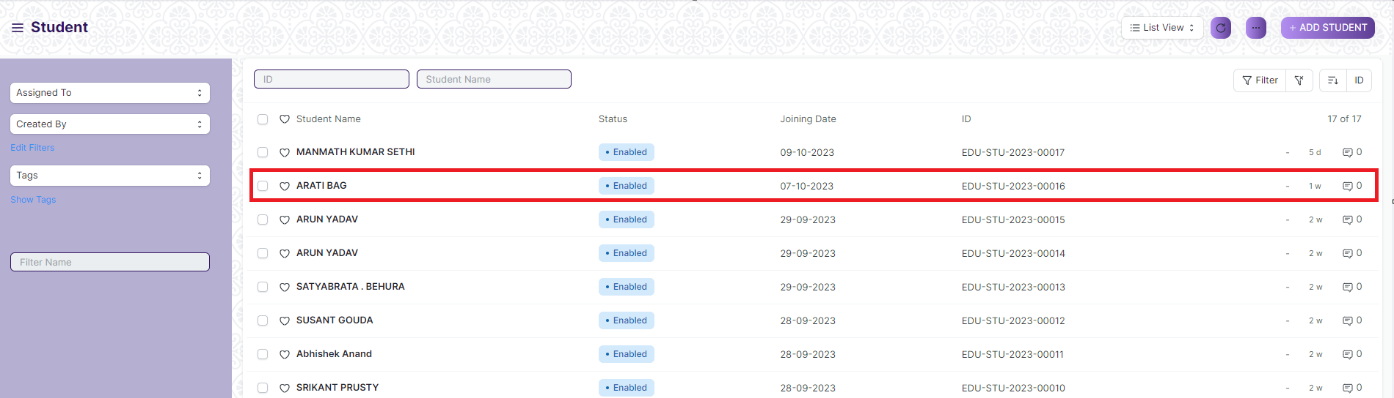(Example : View of “Arati Bag” Document of Student Screen)

1. View the clicked document.

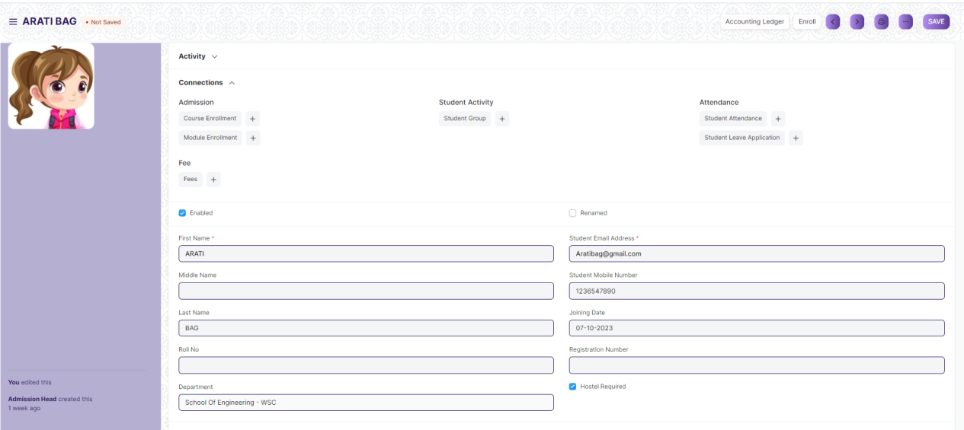

(Example : View of the “Arati Bag” Student)

**Note :** The process of view can only be carried out by user who have necessary permission. Kindly refer to the Screen wise permission section in the document.

**Delete a Saved Document**

1. Log in to the system
2. Go to the required workspace
3. Go to the required screen.
4. Click on the required document from the list view of the screen.
5. Click on the 3 dots in the right corner of the screen.
6. Click on *“****Delete”*.**

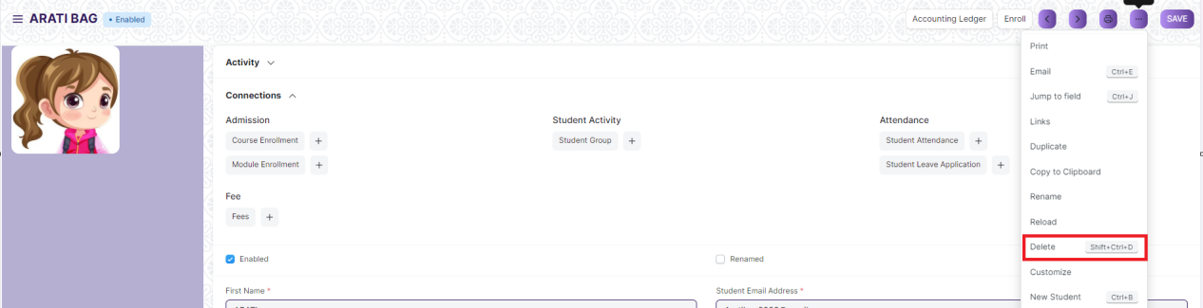

(Example : Deletion of “Arati Bag” document of Student)

1. Click yes if you want to delete the selected document.

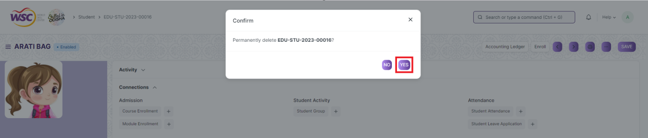

(Example : Clicking Yes to Delete permanently the document)

**Note :** The process of deletion can only be carried out by user who have necessary permission. Kindly refer to the Screen wise permission section in the document.

**Rename a Saved Document**

1. Login to the screen.
2. Go to the required workspace
3. Go to the required screen.
4. Click on the required document from the list view of the screen.
5. Click on the 3 dots in the right corner of the screen.
6. Click on *“****RENAME”*** .

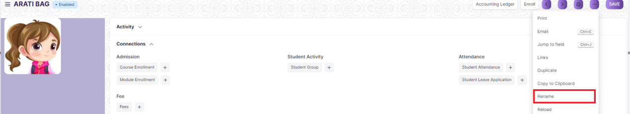

1. Click on *“****Rename”*** button to rename the document.

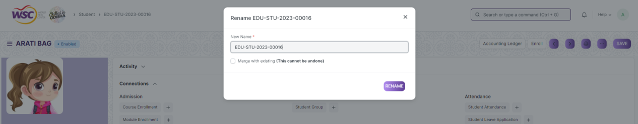

**Note :** The process of deletion can only be carried out by user who have necessary permission. Kindly refer to the Screen wise permission section in the document.

**Print a Saved Document type**

1. Login to the system
2. Go to the required workspace
3. Go to the required screen.
4. Click on a saved document in the screen.
5. Click on the print button present in the right corner of the screen.

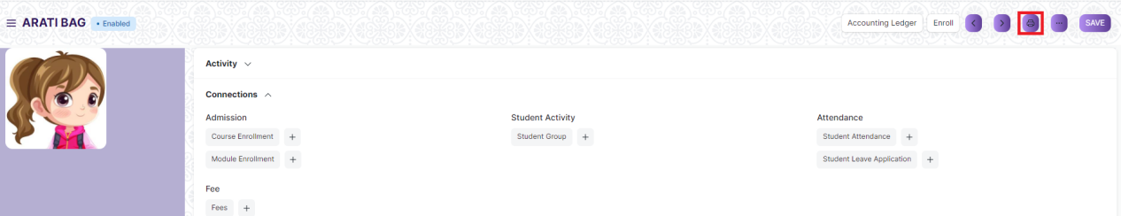

1. A new screen will open.
2. Click on the print button to Print the document.

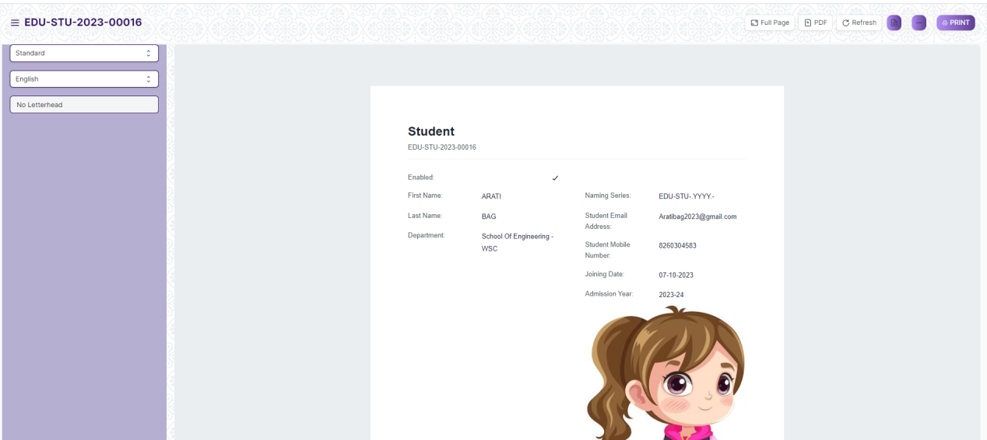

1. To download the employment type as PDF , click on the PDF button .

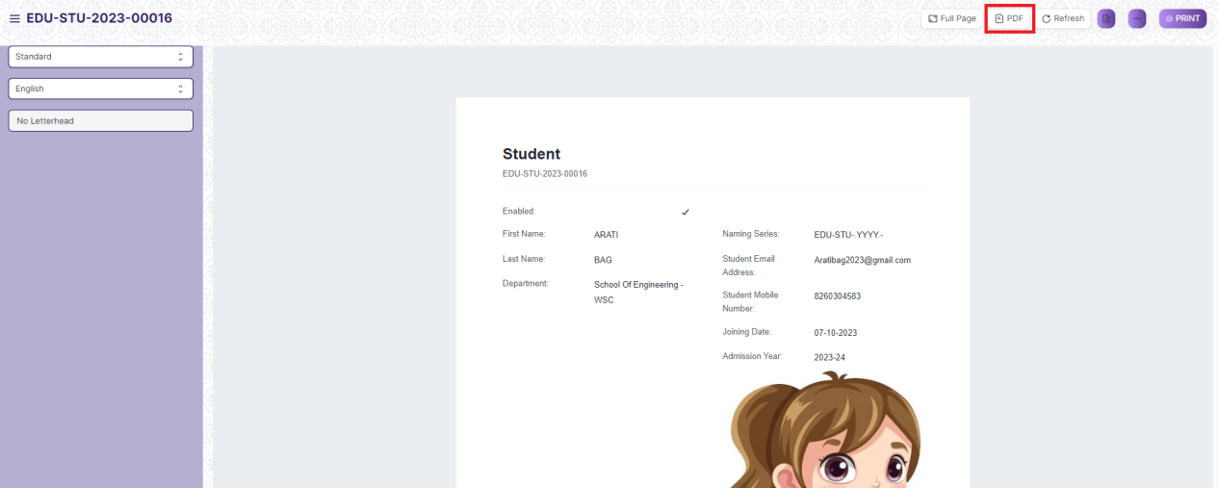

**Note :** The process of printing can only be carried out by user who have the necessary permission.

**View the saved document in different format.**

1. Login to the system
2. Go to the required workspace
3. Go to the required screen.
4. Click on the List View Button in the screen.

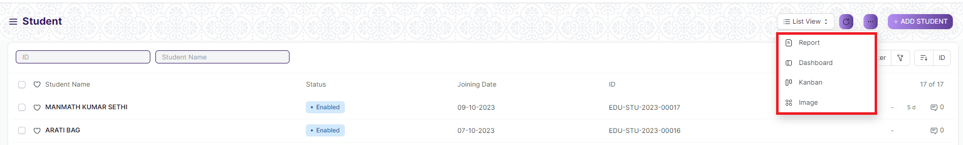

1. Select the appropriate view type that you want.

**Note :** The List view button can only be showed to the user who have necessary permission.

**View the saved documents by applying filters.**

1. Login to the screen.
2. Go to the required workspace.
3. Go to the required screen.
4. Click on the ***“Filter”***.

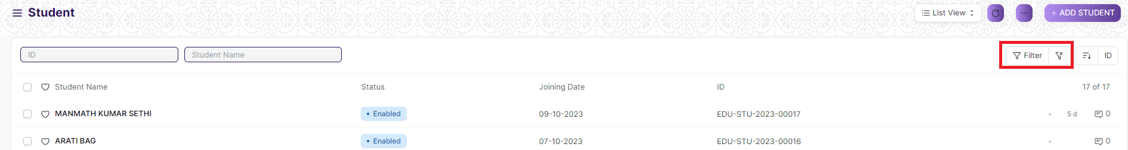

1. Select the field of the document based on which you wish to filter the records. All the fields in a form will be selectable in this list.

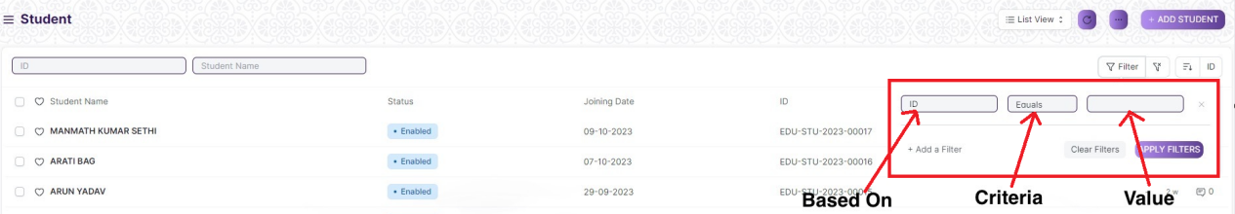

**Based On :** For the field, you will be required to put a value of the field. In the 'based on' field.

**Criteria :** You can define criteria based on which the system will search the document.The different conditions on which the filters are based are: Equals, Not Equal, Like, Not Like, In, Not In, =,>,< etc.

**Value :** Here, you will be required to enter the value for which you are running the document search.

**Some Examples of Viewing the documents in the list view after applying filters.**

Filter on Student Group screen where Group Based On to Batch. After clicking the Apply Filter button, all the filtered document will show in the screen.

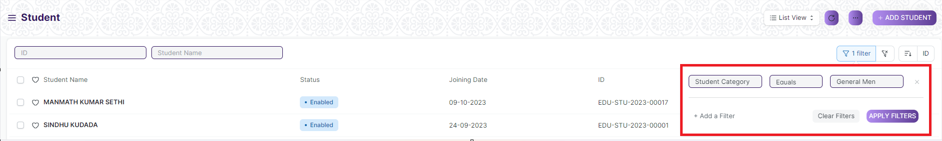

Filter on Student Screen where, the Student Category is equal to General Man.



You can also apply multiple filters at a time. To remove a specific filter, just click on 'x' sign on it. To add another filter Click on the +Add a Filter button.

**Example of Multiple filter .**

Applying filter in the Student screen , where Student Category is equal to General Man and Cast Category is equal to General.

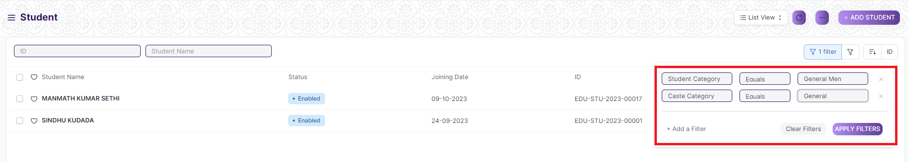

**Default Filters**

There are some filters present out of the box for the views which can be used for filtering the search results.

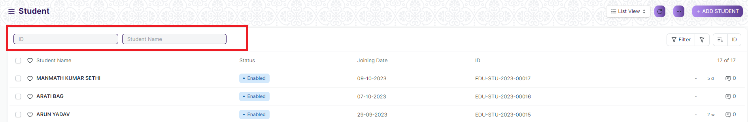

**Note :** The Filter Option can only be showed to the User who have necessary permission.

### **General Procedure for a Submittable Screen**

**Create of New document**

1. Login in to the system
2. Go the required workspace
3. Go to the required screen.
4. Click on the ***“+Add Screen Name”*** button in the right corner of the screen.

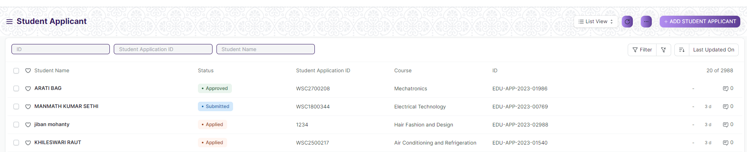

(Example : For addition in the new Student Applicant Type , click +Add Student Applicant button).

1. Enter the required information in the document.
2. Once you are finished entering the information , click the ***“Save”*** button.
3. After saving it , a submit button will appear.

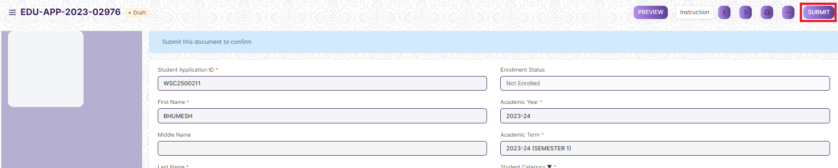

1. Click on the **“Submit”** button.
2. A confirmation dialog box will appear . Click the Yes button to submit the document.

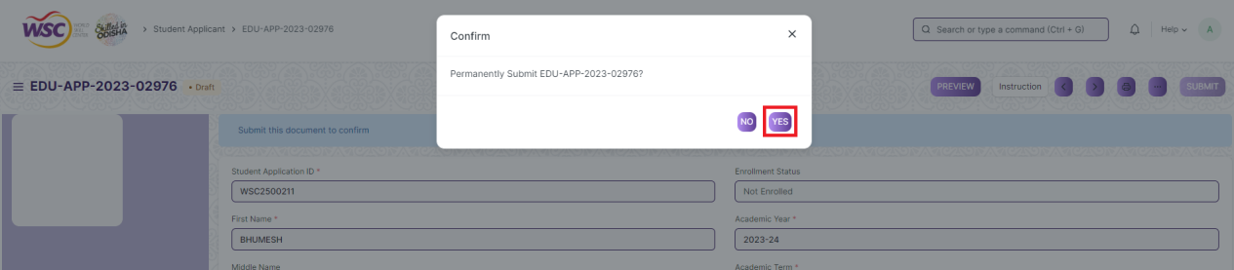

1. After submitting , the record will be visible in the List View of the screen.

**Note :** The process of creation can only be carried out by user who have necessary permission. Kindly refer to the Screen wise permission section in the document.

**Cancel a Submitted Document**

1. Log in to the system.
2. Go to the required workspace
3. Go to the required screen.
4. Click on the required document from the list view of the screen.
5. Click the ***“Cancel”*** Button .

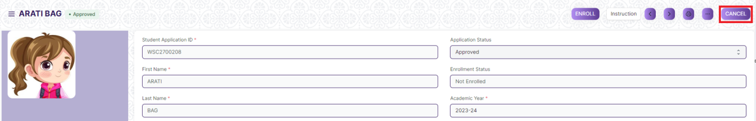

1. A confirmation dialog box will appear . Click the Yes button to cancel the document.

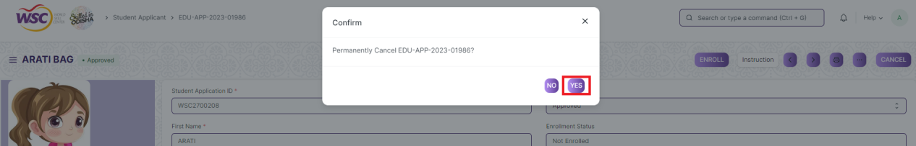

**Note :** The process of cancellation can only be carried out by user who have necessary permission. Kindly refer to the Screen wise permission section in the document.

**Amend a Submittable Document**

1. Log in to the system.
2. Go to the required workspace
3. Go to the required screen.
4. Click on the required document from the list view of the screen.
5. After cancellation of the document , an Amend button will appear on the screen.



1. Click the “***Amend”*** button.
2. A new document will be created with the same information as the original document .

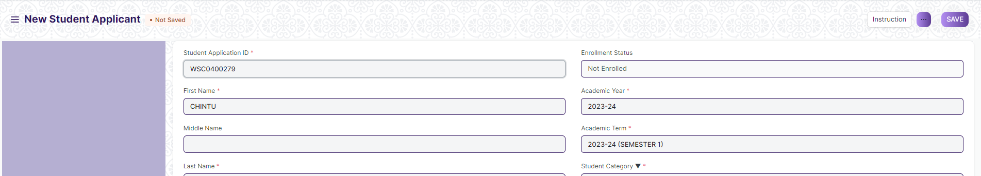

1. You can now make changes to the document as needed.

**Note :** The process of Amend can only be carried out by user who have necessary permission.Kindly refer to the Screen wise permission section in the document.

**Delete a Submittable Document**

1. Log in to the system.
2. Go to the required workspace
3. Go to the required screen.
4. Click on the required document from the list view of the screen.
5. If the document is in draft sate , you can follow the procedure to delete a save document .
6. If the document is submitted , then cancel it first , then delete it.

After cancellation of the document , an Amend button will appear on the screen.

**Note :** If the document you are deleting is linked with any other document , then cancel the dependent document first , then try to delete it.

Example :

In the Student Applicant Screen, when an Student Applicant record is Approved , then a record in the student screen will be created. it is not allowed for deletion of the Student Applicant record until the associated Student is canceled or deleted.

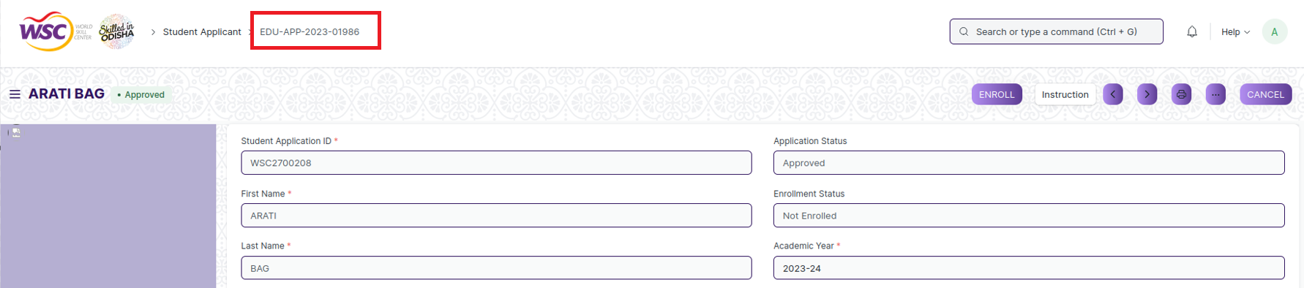

(Student Applicant Record **EDU-APP-2023-01986** linked with Student **EDU-STU-2023-00016** )

On deletion of student applicant record ,It will show the following message ,

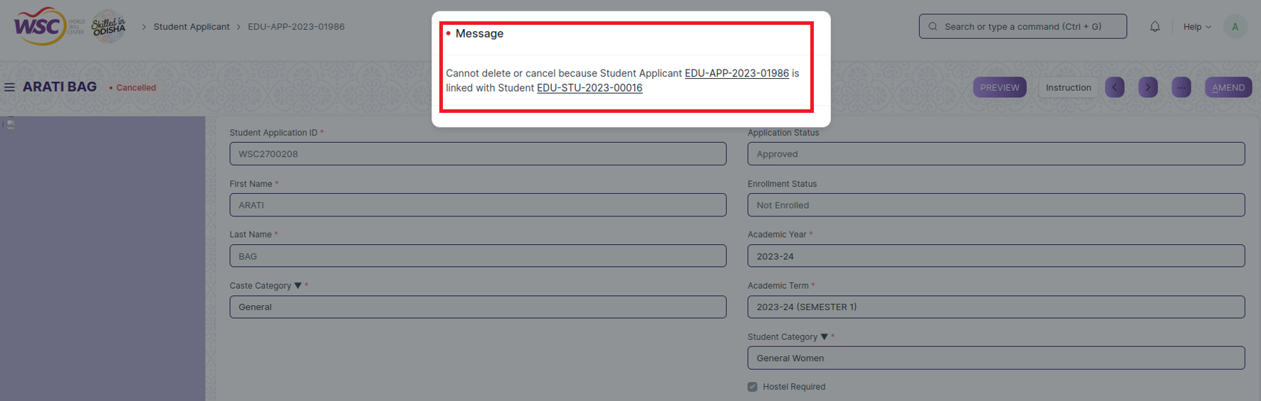

So go the following Student record document(**EDU-STU-2023-00016)**, and cancel or delete it first . After cancellation or deletion, user will able to delete the Student Applicant record (**EDU-APP-2023-01986)**.

**Note :** To initiate the cancellation process, kindly click on the link labeled **'EDU-STU-2023-00016**,' which corresponds to the Student record."

**Action Menu on a document.**

The three dots menu, located in the right corner of a document in a Screen , offers a range of actions and options to manage and interact with the document.

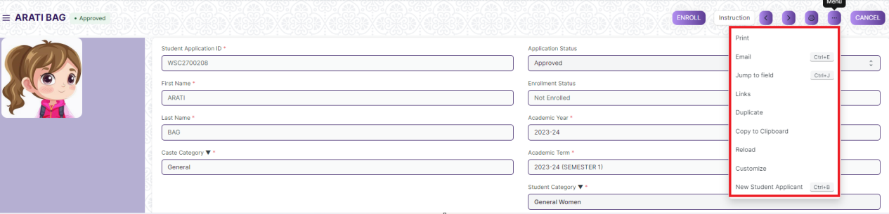

The functionalities available in the three dots menu are given below .

**Print :** Print Enables you to generate a printable version of the document ., which you can save as a PDF or send to a printer.

**Email/Bulk Email :** Click on Email allows you to send the document as an attachment via email to specified recipients.

**Duplicate :** Create a new document with the same information as the current one.

**Delete :** Permanently remove the document.

**Cancel :** Cancel the submitted document.

**Submit :** Submit the document . If the document is submittable.

**Links :** This Option displays a list of document that are linked to the current document. You can navigate these linked documents from here.

**Jump to field :** You can directly go the required field by clicking this option and giving appropriate field name.

**Copy to Clipboard :** By clicking this option you can copy the content of the document .

**Rename :** By clicking the Rename option you can Rename the document.

**Note :** These options will be visible to User who have necessary permission.

## Department

A Department is a specialized functional area or a division within an organization.You can configure the Departments in your organization, set Leave Block List, and also Leave and Expense Approvers for the same.

To access the Department, go to:

**Home > Admission > Masters > Department**

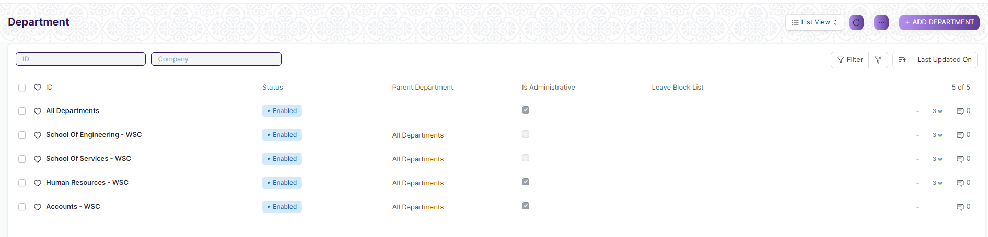

Department list view

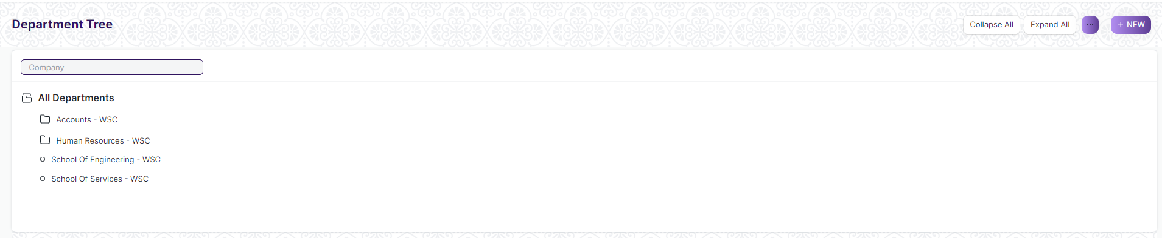

Department is a tree-structured master, which means you can create parent departments and sub-departments as shown below:

#### Prerequisites

Before creating a Department, it is advisable you create the following documents:

* Company
* Leave Block List

#### How to create a Department

1. Go to the Department list

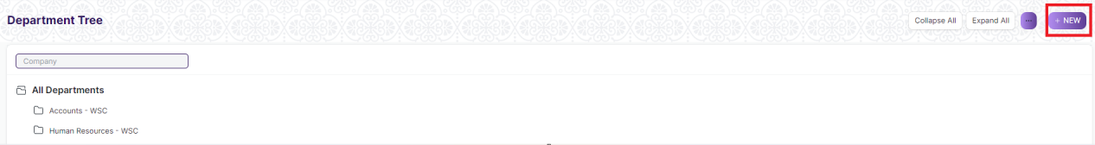

1. Through tree view Click on New (or)

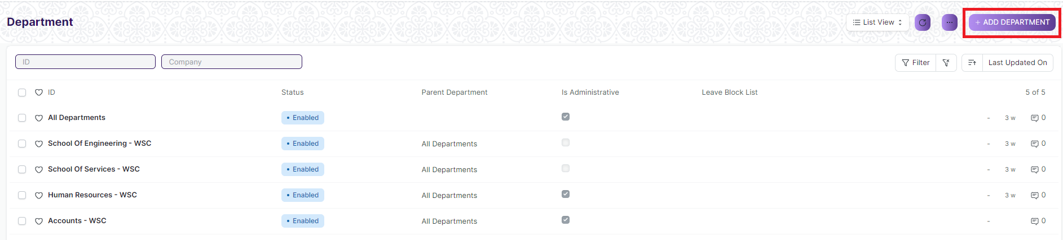

1. Through list view Click on “Add Department”.

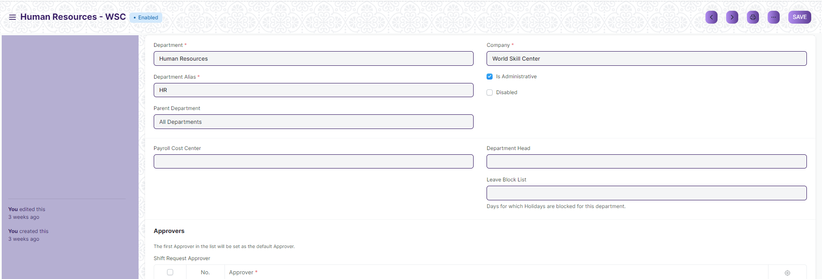

1. Enter Department name.
2. Select Company name.
3. Select “Is Group” and “Is Stream” if there are any child department under the parent department.
4. Select Leave Block List (optional) applicable for this department.
5. Click on Save.

## Course Type

A Course Type is a specialized functional area or a division within the Department. You can add Course type, modify and Courses can be linked to it.

To access the Course Type, go to:

**Home > Admission > Masters > Course Type**

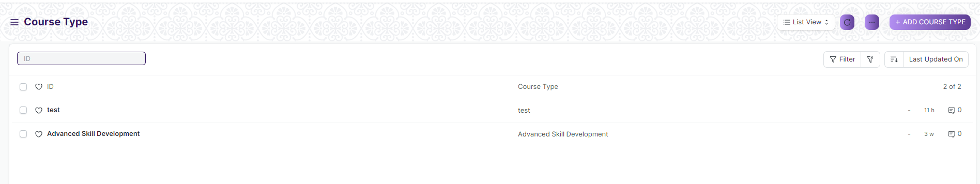

#### How to create a Course Type

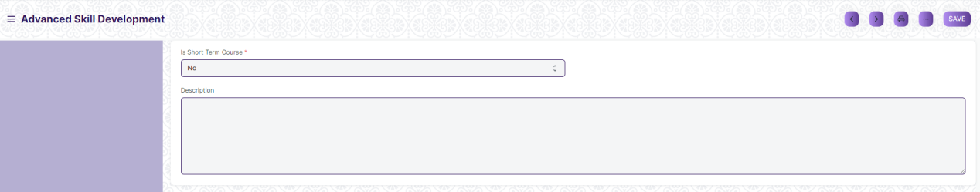

1. Go to Course Type list, click on Add Course Type
2. Enter Course Type Name and Description
3. Select Yes or No in “Is Short Term Course”, where you mention course is for short term or long term
4. Click on Save.

## Courses

A Courses will have an educational curriculum defined by your institute to streamline the learning process and goals in each subject or course.

To access the Courses, go to:

**Home > Admission > Masters > Courses**

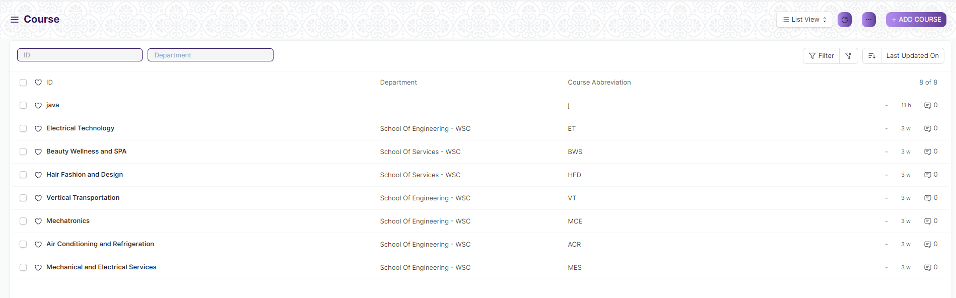

#### Prerequisites

To create a New Courses, it is advised to create the following first:

1. Department
2. Course Type

#### How to creates a Courses

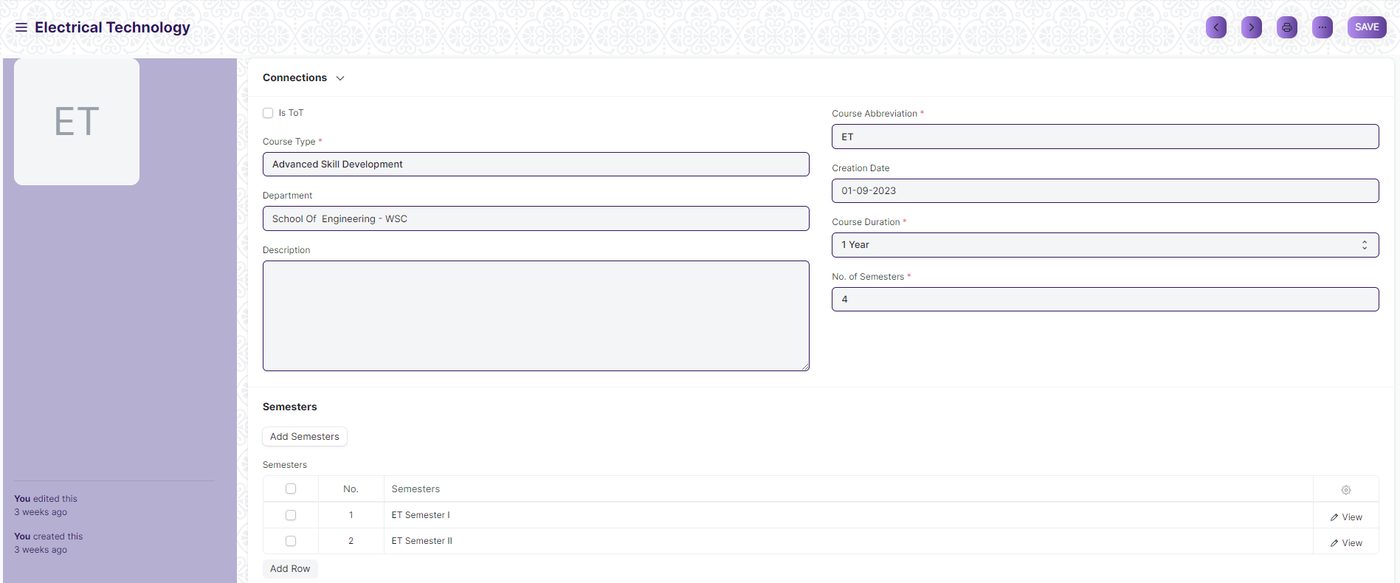

1. Go to the Courses list and click on New Course.
2. Enter the Course Name and the Course Abbreviation.
3. Select the Department, Course Type.

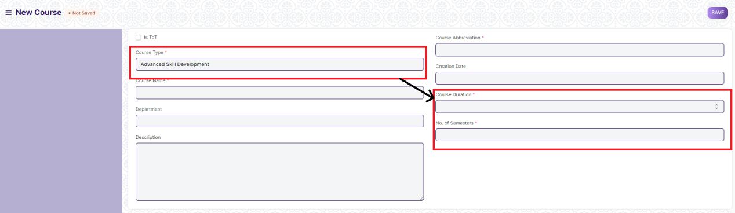

1. If you Select Course Type then two field will visible where you mention course duration and number of semester
2. Enter Creation date and Description.

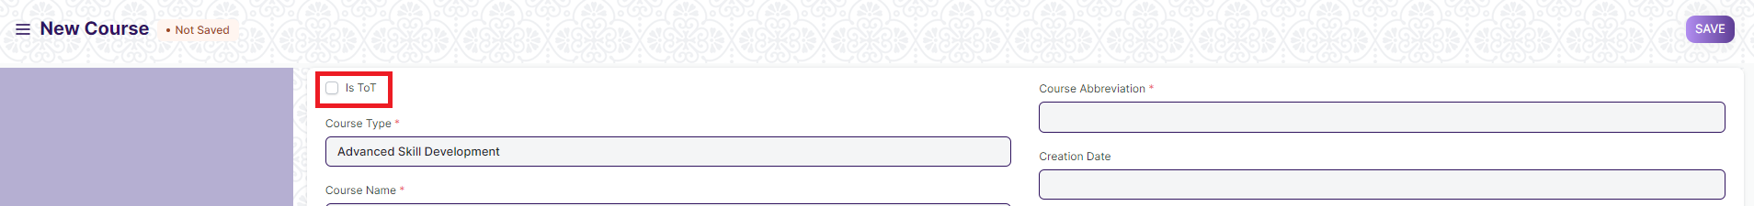

1. Check “is ToT” if this data are required for ToT
2. Click on Save then Button and Table will fetch.

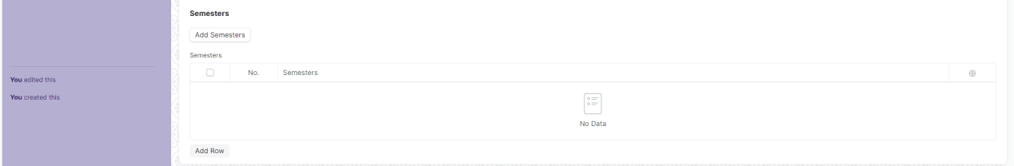

1. When you click on button then semester will fetch on table.

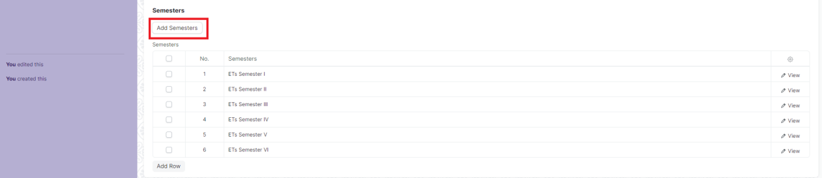

## Semester

A semester is individual part of a Courses. A semester system divides the academic year into different sessions which have various course enrollments enlisted in them.

To access the Courses, go to:

**Home > Admission > Masters > Semester**

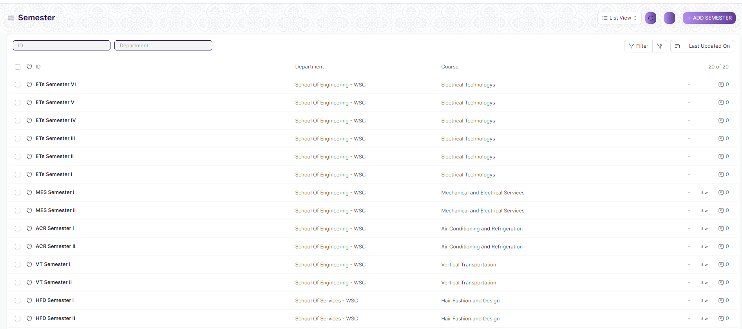

#### Prerequisites

To create a New Semester, it is advised to create the following first:

1. Courses

#### How to creates a Semester

1. Method 1:

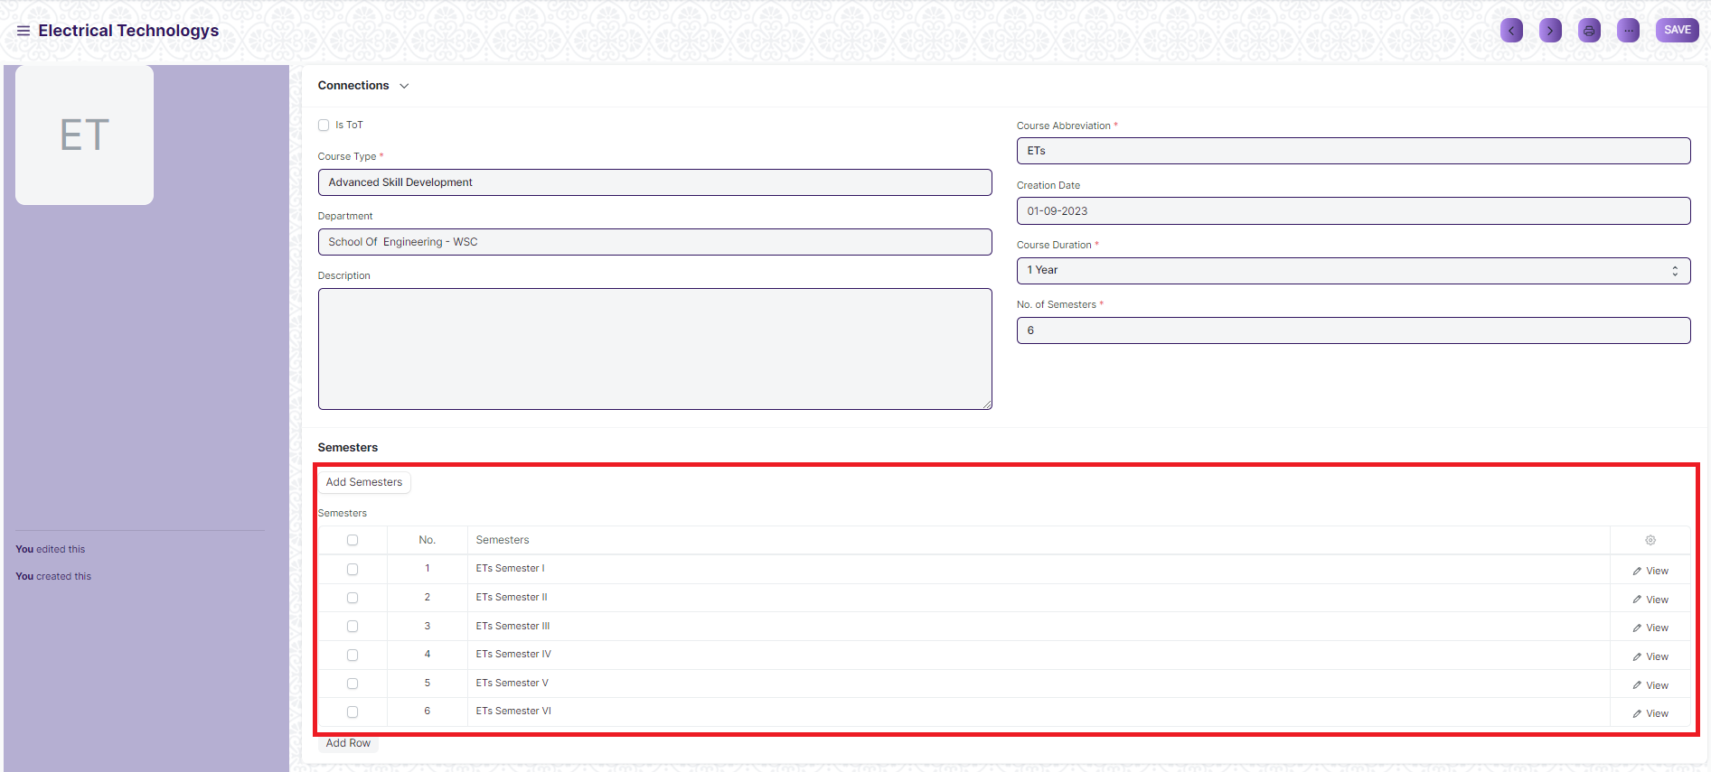

* 1. Upon saving the Courses User can add Semesters in the Semesters table and save the Courses.
  2. The semesters get automatically saved and linked with the respective Courses.

1. Method 2:

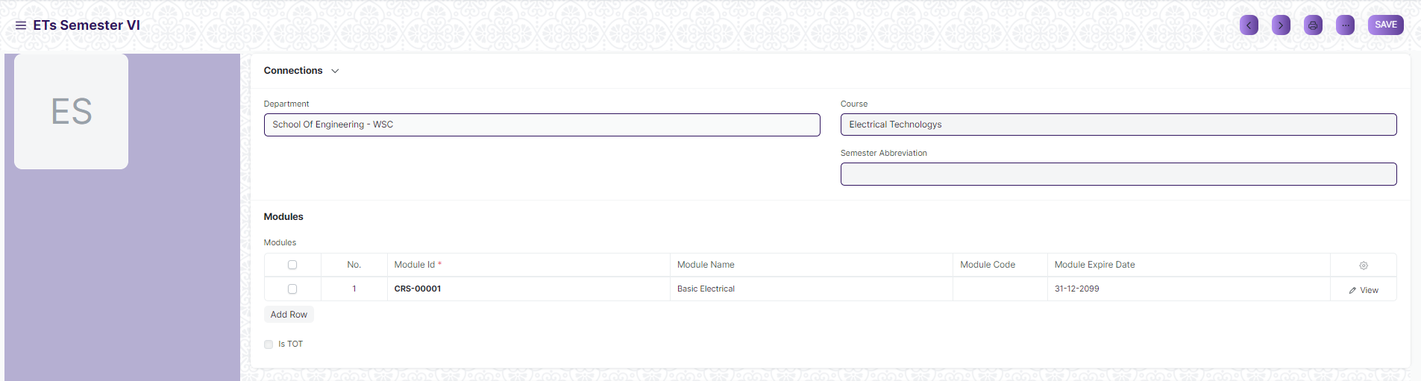

* 1. Go to the Semester list and click on add Semester.
  2. Select and enter the Semester Name.
  3. Select and enter Course.
  4. Select and enter the Semester Abbreviation.
  5. Select and add Module on table if required.
  6. Click on Save.

## Modules

A Module can be considered as a subject or a part of an educational Courses which is to be taught for a term.

A Module will have a set of topics that are to be covered under its scope.

To access the Modules list, go to:

**Home > Admission > Masters > Modules**

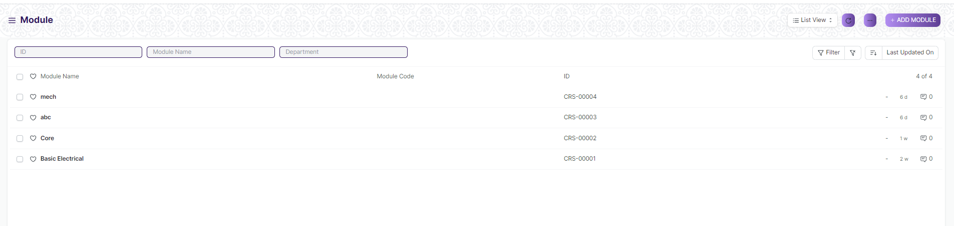

#### Prerequisites

Before creating a Module, it is advised to create:

1. Department
2. Topics
3. Module Type

#### How to creates a Modules

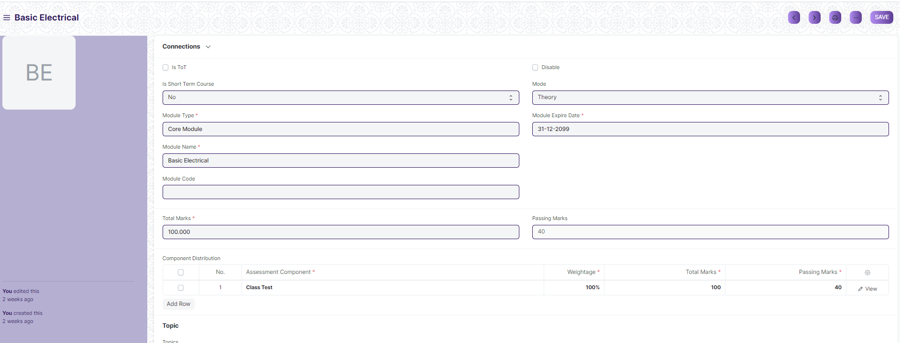

1. Go to Module List and click on New.
2. Select Module Type, Module Expire Date and “Is Short Term Course”
3. Select Mode as Theory, Practical or Both according to requirement for that module.
4. Check “Is ToT” if module required for ToT
5. Check Disable if this module not required for further use
6. Enter the Module Name and Module code and Total Marks for that module
7. Add the Topics. You can also create the topics from here itself.
8. Add the Description for the module.
9. Click on Save, after save Component Distribution table visible.



1. On Component Distribution you can mention Weightage, Total marks and Passing Marks for Assessment Component.

## Topic

A Topic can consider as module content or a subject that you talk, write or learn about.

To access the Topic list, go to:

**Home > Admission > Masters > Topic**

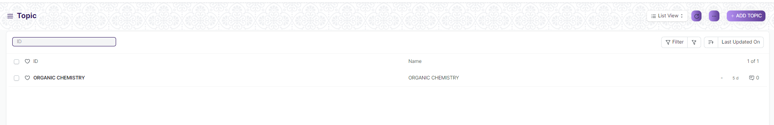

#### How to creates a Topic

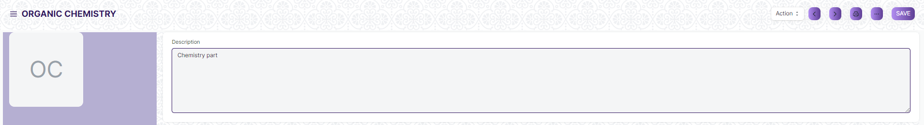

1. Go to Topic List and click on New.
2. Enter Name and Description
3. Click on Save

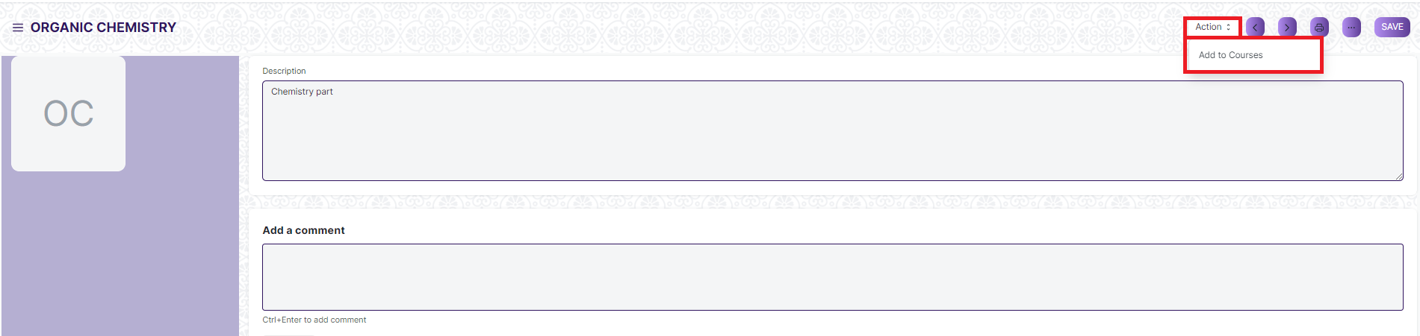

1. After save Action button are visible and through that we can assign Topic on Courses

## Class Rooms

Classroom refers to a tutoring space which can be set as the venue for courses or examinations.

To access the Topic list, go to:

**Home > Admission > Masters > Class Rooms**

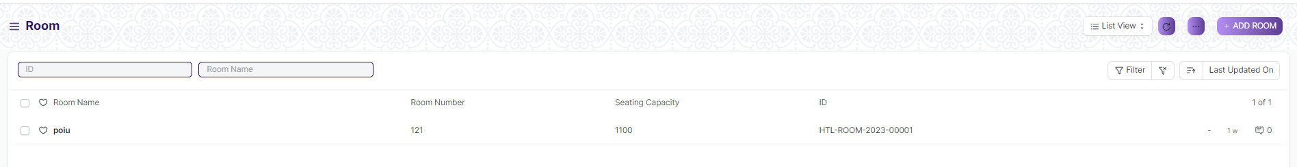

#### How to creates a Class Rooms

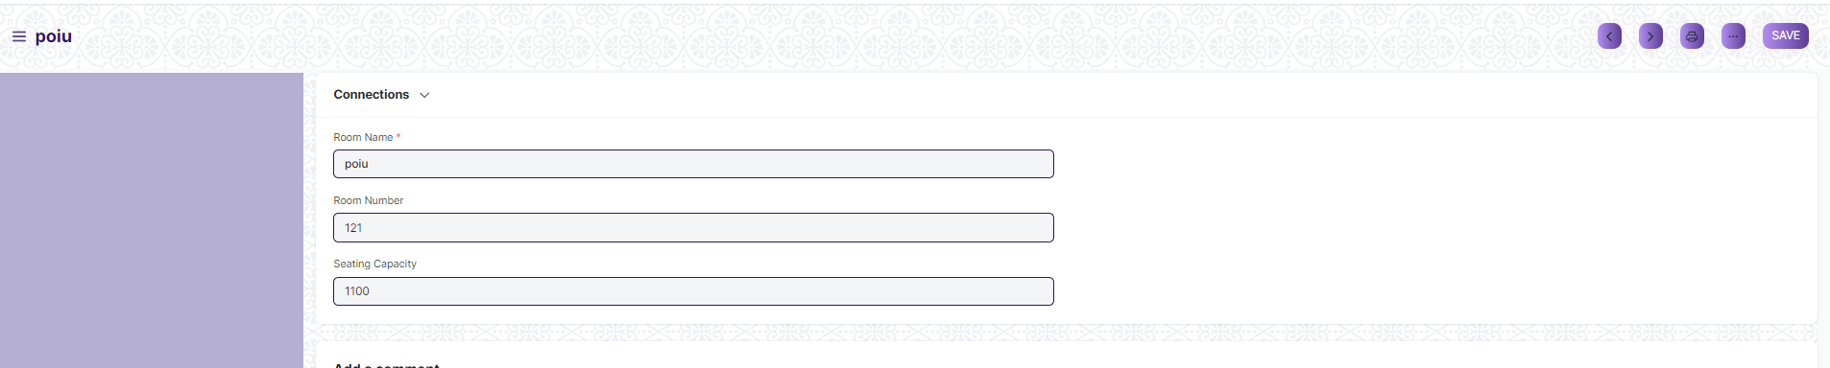

1. Go to the Room list and click on New.
2. Add the name of the room.
3. Add the Room Number for the selected room.
4. Enter the Seating capacity for the room.

**Note**: A Class Room can be further linked to a Course Schedule.

## Academic Year

An academic year is a period which the Educational Institutes, Schools and Universities use to measure a quantity of study.

The Academic year form have the Start and End date for the Academic year. within an Academic Year, you can have multiple Academic Terms. An academic Year can be further liked to a Student Group, which can be created from an Academic Year.

If the Academic Year has been specified in the Education Settings, then it will become the default Academic Term in all the forms and will be editable if required.

To go to Academic Year, go to:

**Home > Admission >Admission Masters > Academic Year**

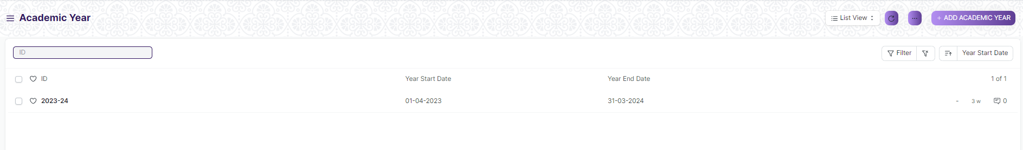

#### How to creates a Academic Year

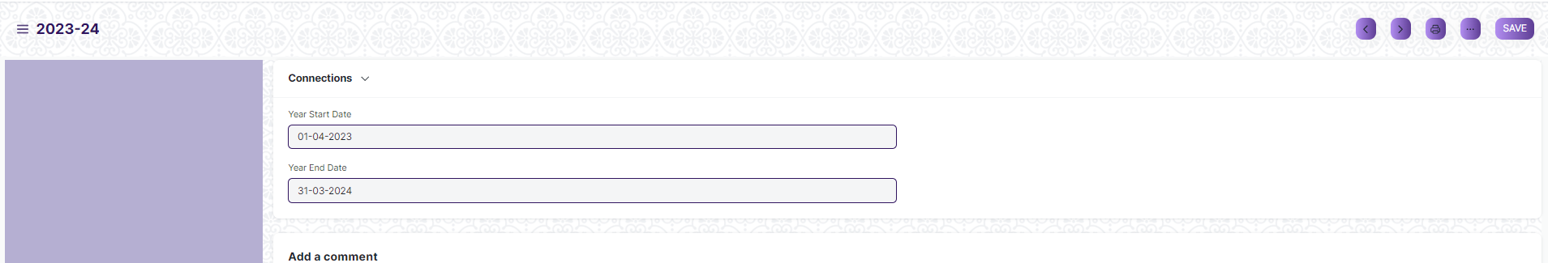

1. Go to the Academic Year list and click on New.
2. Enter Academic Year Name, Year Start Date and Year End Date
3. Click On Save

## Academic Term

An Academic Term would become a part of the Academic Year, during which the Institute will assess its students on the curriculum defined for that term. It could be a Quarter, Trimester or a Semester.

To access Academic term, go to:

**Home > Admission > Masters > Academic Term**

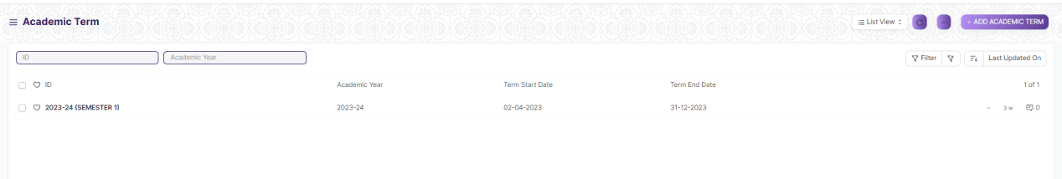

#### Prerequisites

Before creating a Academic Term, it is advised to create:

1. Academic Year

#### How to creates a Academic Term

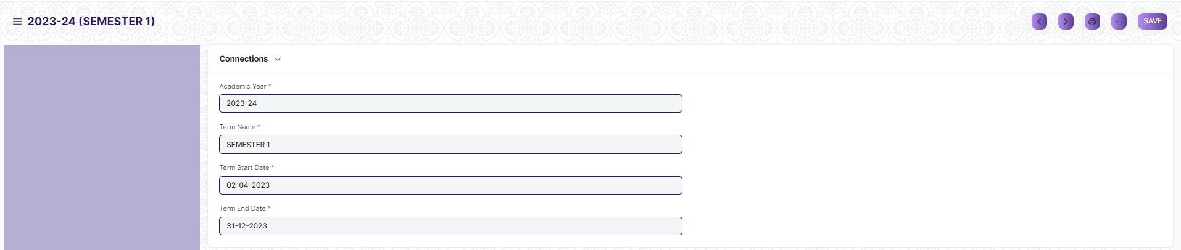

1. Go to the Academic Term list and click on New.
2. Select Academic Year.
3. Enter Term Name, Term Start Date and Term End Date
4. Click On Save

## Academic Events

An Academic Events are individual events which is used for creating Academic Calendar while preparing Schedule for a Class.

To access Academic Events, go to:

Home > Admission > Admission Masters > Academic Events

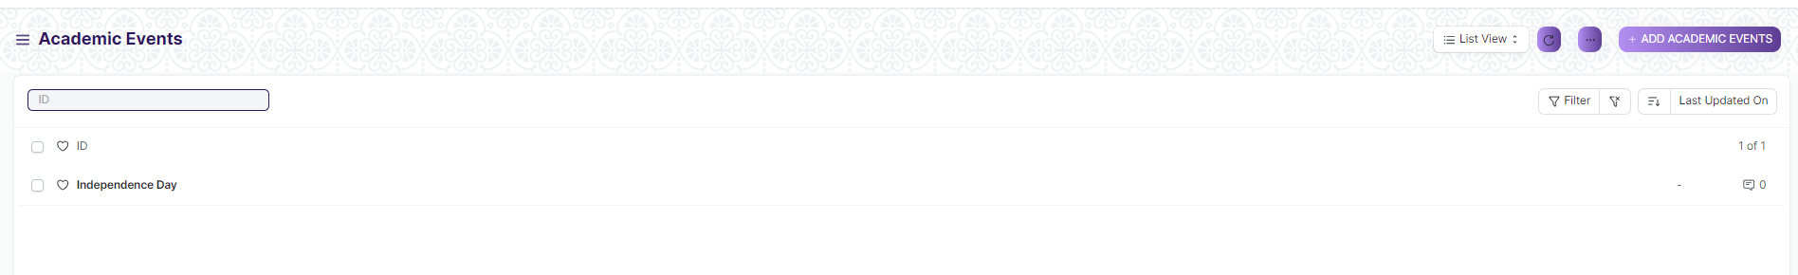

#### How to creates a Academic Events

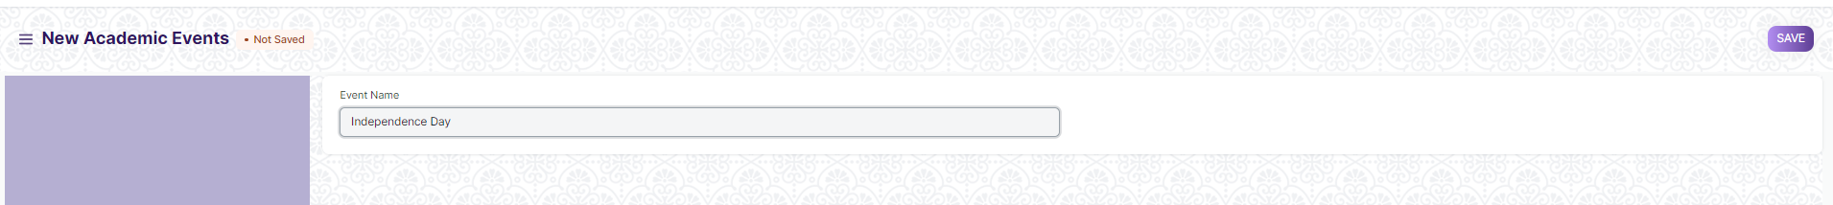

* 1. Go to the Academic Events list and Click on Add Academic Events.
  2. Add Event Name.
  3. Click on Save.

## Academic Calendar Template

Academic Calendar Template is a list of all different events that will be happening in an Academic year for a particular Course.

For Every Course a separate Academic Calendar Template will be created and later be linked while declaring admission for that Course.

To access Academic Calendar Template, go to:

**Home > Admission > Admission Masters > Academic Calendar Template**

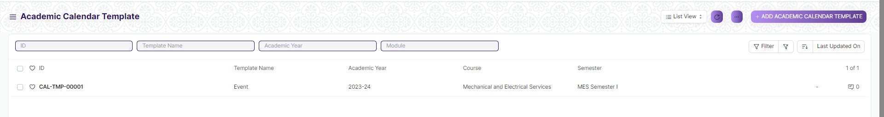

#### Prerequisites

Before creating a Academic Calender Template, it is advised to create:

1. Academic Year
2. Course
3. Academic Events

#### How to creates a Academic Calender Template

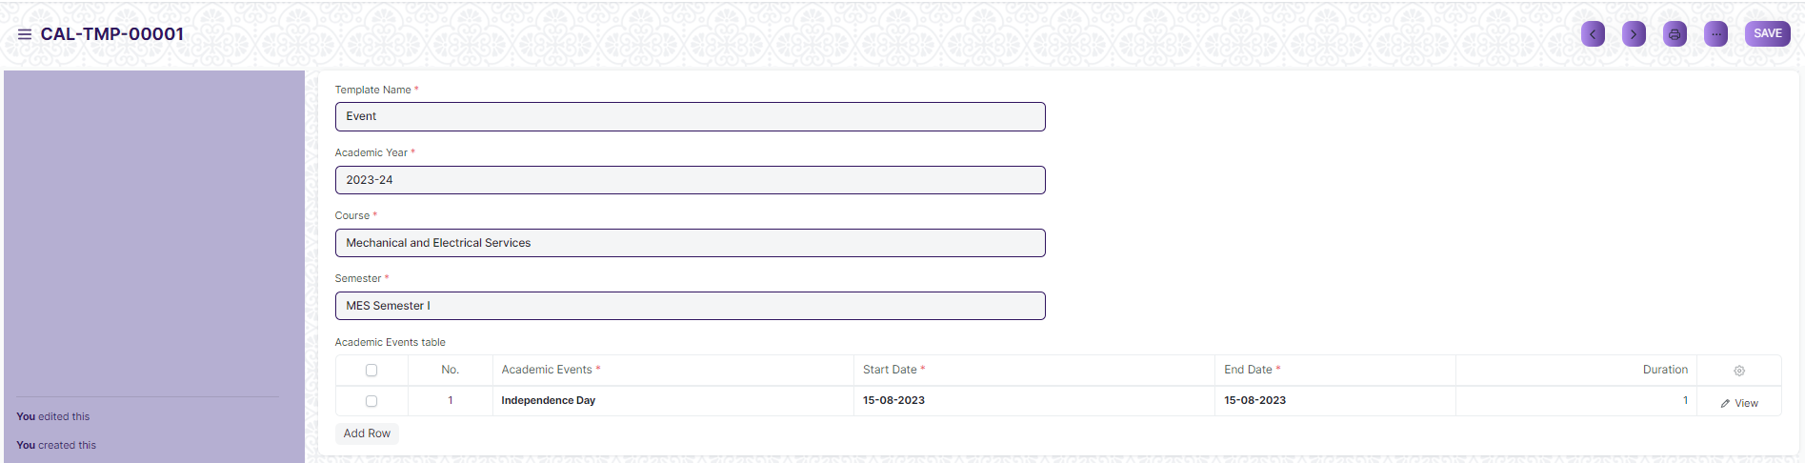

1. Go to the Academic Calendar Template list and Click on Add Academic Calendar Template.
2. Enter Template Name.
3. Select Academic Year, Course and Semester.
4. Select Academic Events and add Starting date, End date for the events on the table.
5. Click on Save.

## Academic Calender

Academic calender is a schedule of all of the events that occur in an academic year. These events may include examination dates, spring break or reading week and the last day of the semester. It can also be useful for prospective students, alumni, and parents as well. Each educational institution creates its own academic calendar with their own defined dates.

To access Academic Calendar, go to:

**Home > Admission > Admission Masters > Academic Calender**

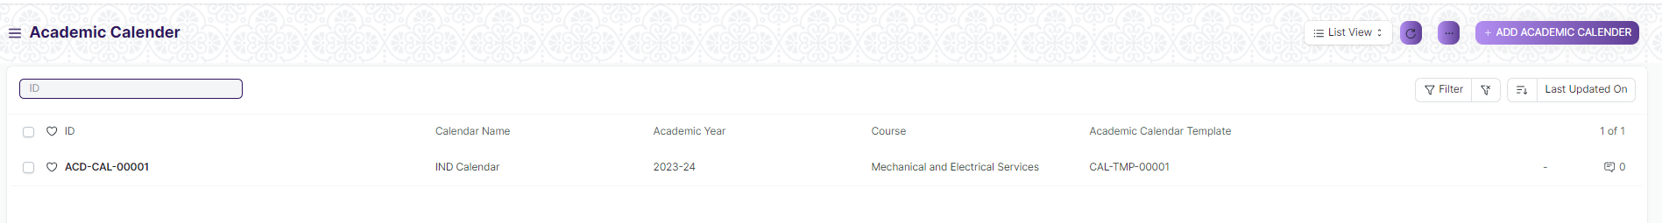

#### Prerequisites

Before creating a Academic Calender, it is advised to create:

1. Academic Year
2. Course
3. Academic Calendar Template

#### How to creates a Academic Calender

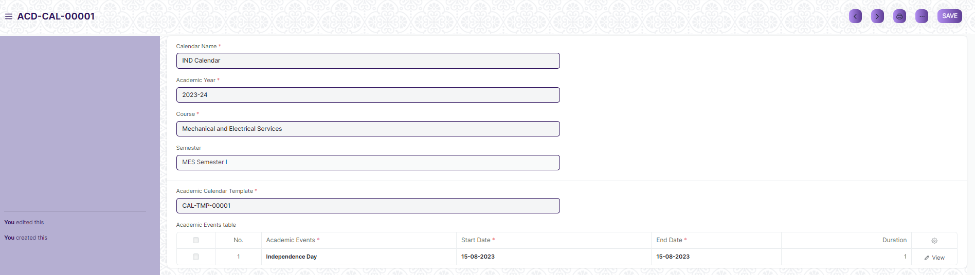

1. Go to the Academic Calender list and Click on Add Academic Calender.
2. Select and enter Calendar Name.
3. Select and enter Academic Year.
4. Select and enter “Course”.
5. Select and enter “Academic Calendar Template”.
6. The details mentioned in Academic Calendar Template is auto-fetched on table.
7. Click on Save and Submit.

## Documents

Documents is a Master form and that data will fetch on Student Applicant and Documents form, according to that data student will provide document on Student Applicant. Eg. 10th Marksheet, Aadhar Card and more

To access Documents, go to:

**Home > Admission > Admission Masters > Documents**

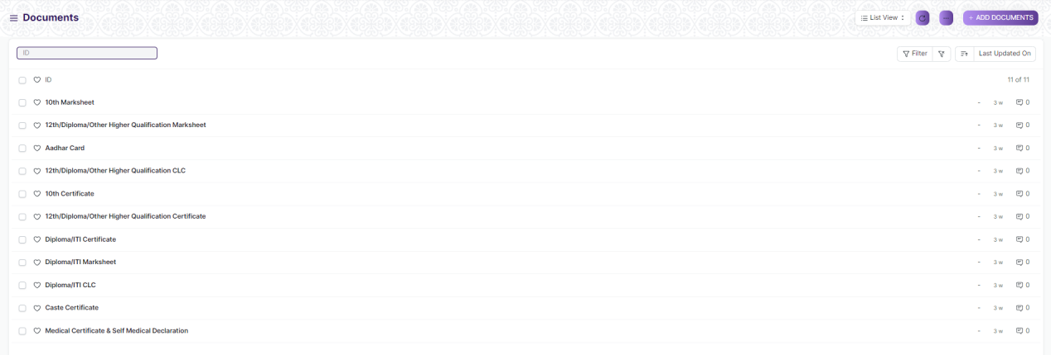

#### How to creates a Documents

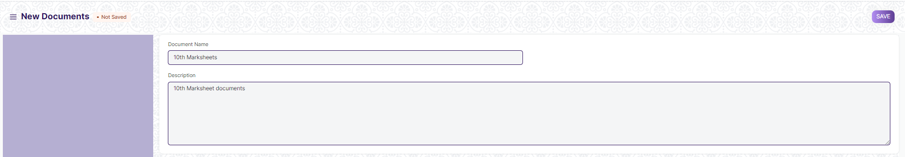

1. Go to the Documents list and Click on Add Documents.
2. Enter Documents Name and Description
3. Click on Save

## Documents Template

Document Template is a list of all the different templates required for getting admission in a particular course. Document Template is primarily used while creating a student admission for a course.

To access Documents Template, go to:

**Home > Admission > Admission Masters > Documents Template**

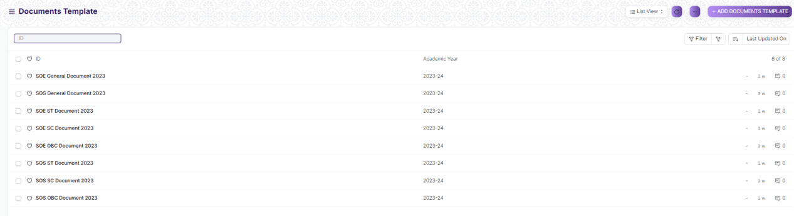

#### Prerequisites

Before creating a Documents Template, it is advised to create:

1. Academic Year
2. Department
3. Student Category
4. Documents

#### How to creates a Documents Template

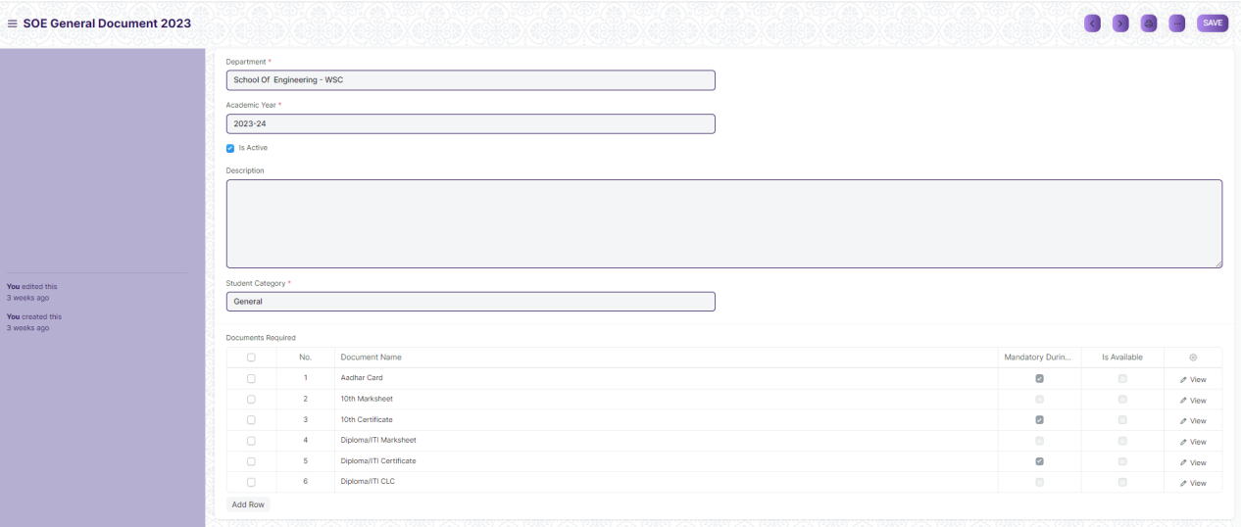

1. Go to the Documents Template list and Click on Add Documents Template.
2. Enter Template Name, Academic Year and Department.
3. Check “Is Active” button.
4. Add Description.
5. Select Student Category from the list of drop down that appears.
6. In the Document Required Table add all the different Documents.
7. Click on Save.

## Eligibility Parameters

An Eligibility Parameter is a label based on which Students eligibility is checked while defining Student admission.

To access Eligibility Parameter, go to:

**Home > Admission > Admission Masters > Eligibility Parameter**

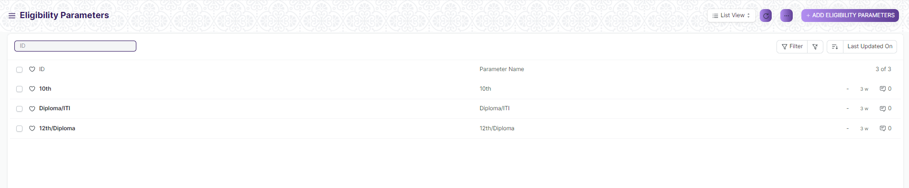

#### How to creates Eligibility Parameters

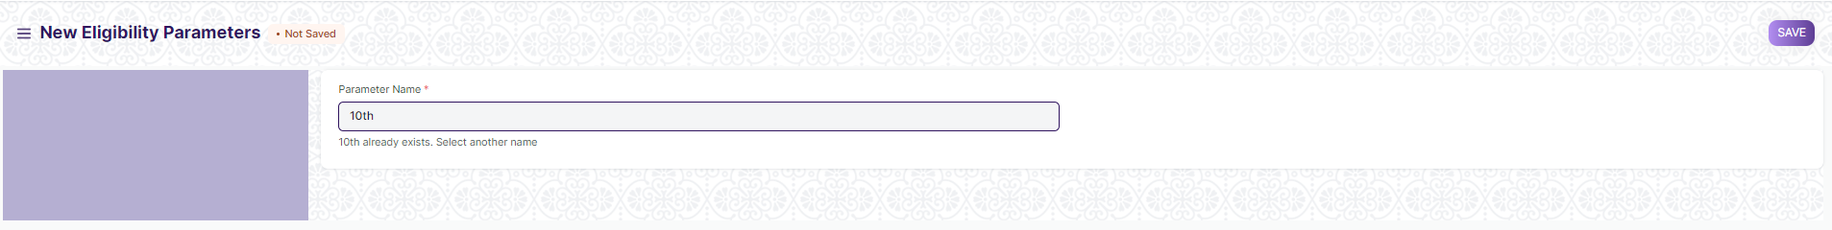

1. Click on Add Eligibility Parameter.
2. Add Parameter name.
3. Click on Save.

## Student

The Student document will hold all the data of any Student in your Academy like their Personal Information, Photo, Date of Birth, Address, etc.

This form will also contain any additional details like the Student's Guardian and Sibling details.

The student is enrolled in a Course when the application is approved. Once the enrollment is done the Student Applicant status is update to Admitted.

To access Student, go to:

**Home> Admission > Student & Trainer> Student**

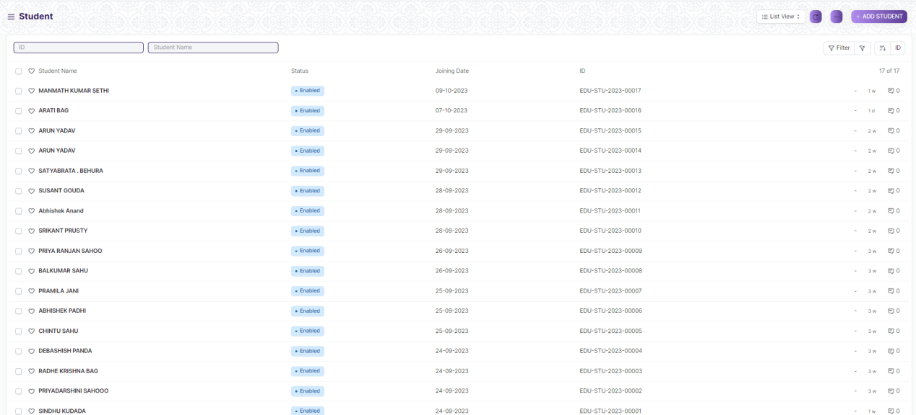

#### Prerequisites

Before creating a Student, it is advised to create:

1. User (If Applicable)

#### How to creates a Student

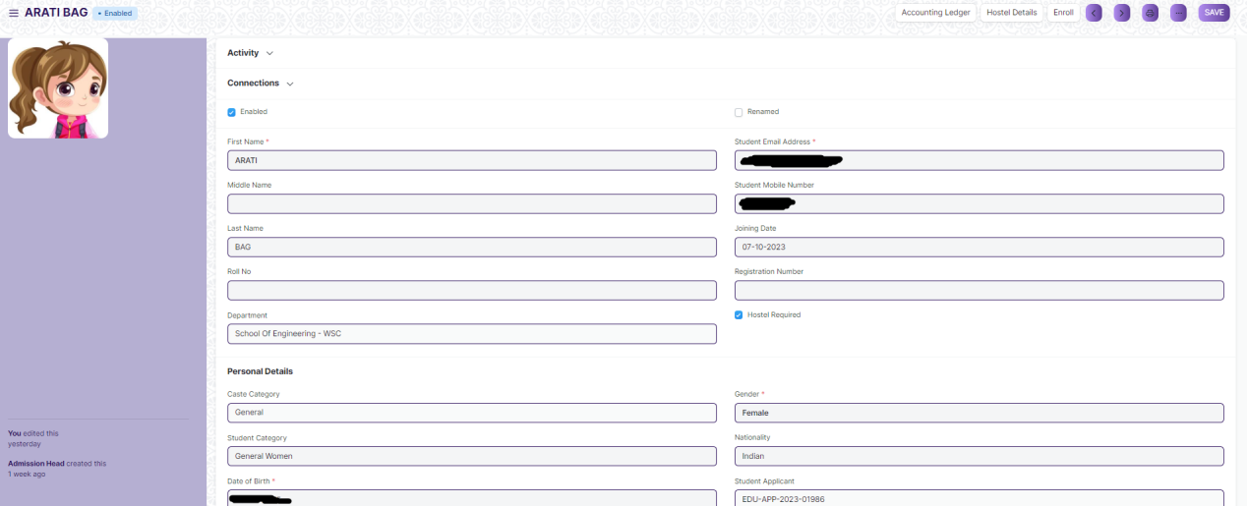

1. Go to the student list and click on New.
2. Enter the First Name, Middle Name and Last Name of the student.
3. Enter other details like Student Email Address, User ID (If Applicable) and Joining Date.
4. Click on Save.

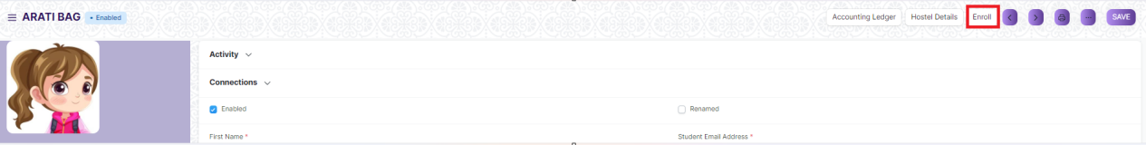

1. User can create course enrollment through student enroll button.

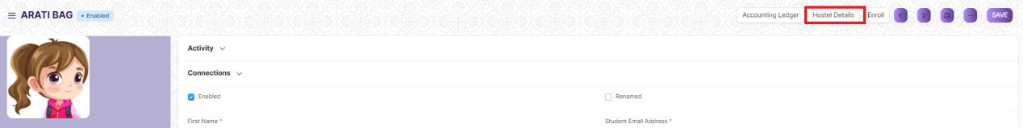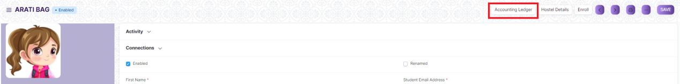

1. User can view hostel detail and account ledger through button.

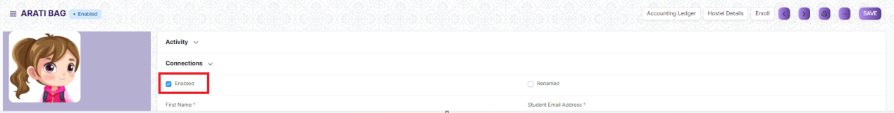

1. User can disable student if user unchecked “Enabled”

**Note**: Student data will auto created when student applicant for will approved for that student

## Trainer

An Trainer is a teacher, tutor, or a professor that will be responsible for teaching a particular topic or course to the students.

This document can be used to maintain the Trainer Log in the form of a list of topics/courses covered by the Trainer. This log will have the entire history of the courses taught by the Trainer.

To access the Trainer list, go to:

**Home > Admission> Student & Trainer > Trainer**

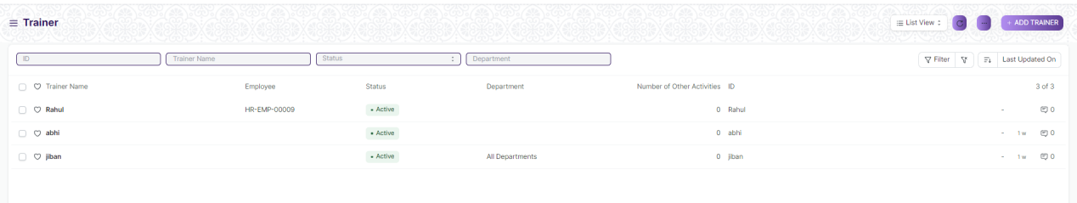

#### Prerequisites

Before creating a Trainer, it is advised to create:

1. Employee(If Trainer are not Guest)

#### How to creates a Trainer

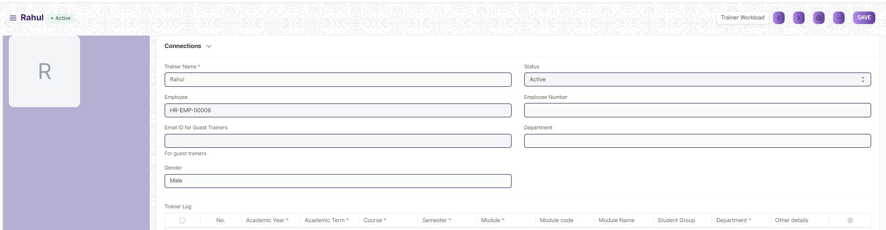

1. Go to the Trainer list and Click on New Trainer.
2. Enter the Trainer Name/Employee for the Trainer.
3. Select the Department for which you are creating an Trainer.
4. Enter Trainer Log and Other Activities Table data
5. Click on Save.

#### Features

**Trainer Log**

* Academic Year: The Academic Year for which the Trainer is created.
* Academic Term: The Academic Term for which the Trainer is created.
* Department: The department to which the Trainer belongs to.
* Course Type: The Course Type for which the Trainer Log is being made.
* Course: The course for which the Trainer Log is being made.
* Student Group: The Student Group for which the user is making the Trainer Log.
* Other Details: Any other details regarding the Trainer Log can be recorded here.

## Student Category

Student Category allows you to classify the students based on various categories.

In Institutions, there may be fee concession for some categories such as Handicapped Students, Foreign Nationals, Reserved Categories by the government, etc.

When a Student is enrolled for a Course, you can select the Category for the Student.

To access Student category, go to:

**Home > Admission > Student & Trainer> Student Category**

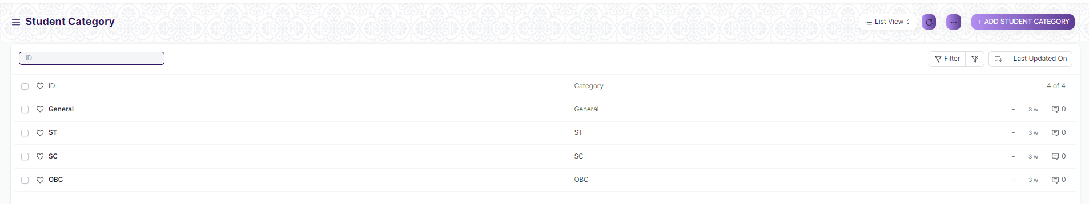

#### How to creates a Student Category



1. Go to the Student Category list and Click on New Student Category.
2. Enter Category
3. Click on Save.

## Student Batch

A Student batch is a collection of students from within Student Groups.

For example, a group of students studying the same Course together will be called a Student Batch.

To access Student category, go to:

**Home > Admission > Student & Trainer> Student Batch**

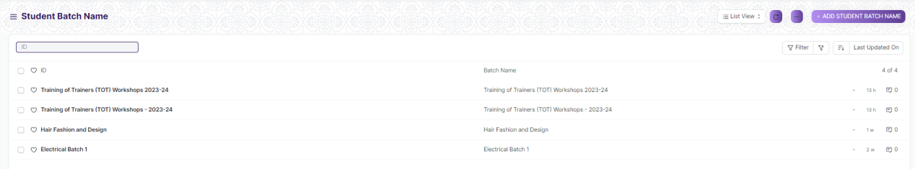

#### How to creates a Student Batch

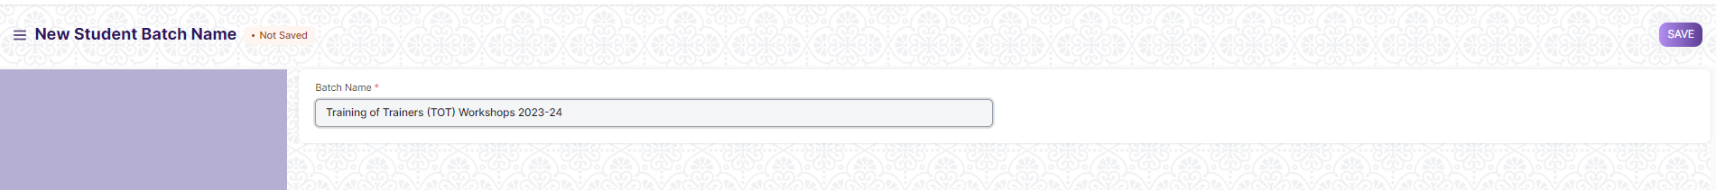

1. Go to the Student Batch list and Click on New Student Batch.
2. Enter Batch Name.
3. Click on Save.

## Student Admission

Student Admission is a document which can be configured to initiate an Admission Process for your institution by publishing it on the EduLead generated website.

To access student Admission, go to:

**Home > Admission > Student Enrollment > Student Admission**

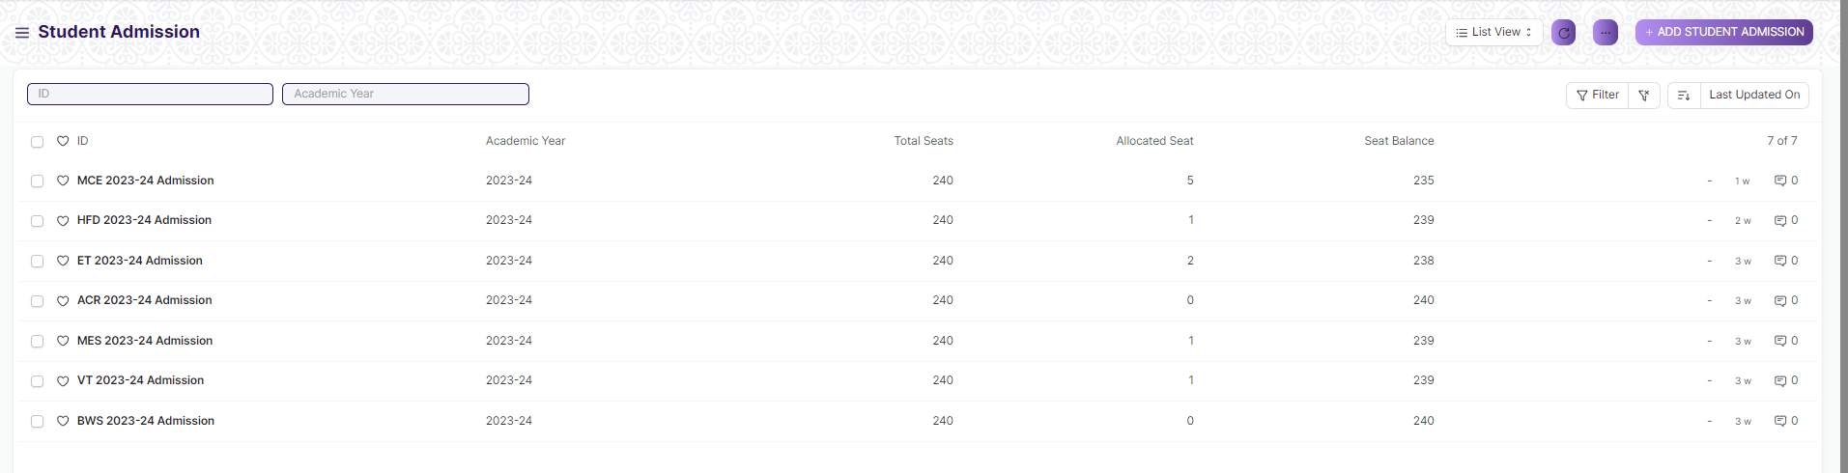

#### Prerequisites

Before creating a Student Admission, it is advised to create:

1. Course
2. Department
3. Semester
4. Academic Year
5. Academic Term

#### How to creates a Student Admission

1. Go to Student Admission list and click on New.
2. Enter Title, Application Start Date and Application End Date for student admission portal.
3. Select the Admission Course,Course Type,Semester,Academic Term and Academic Year for the Student Admission.

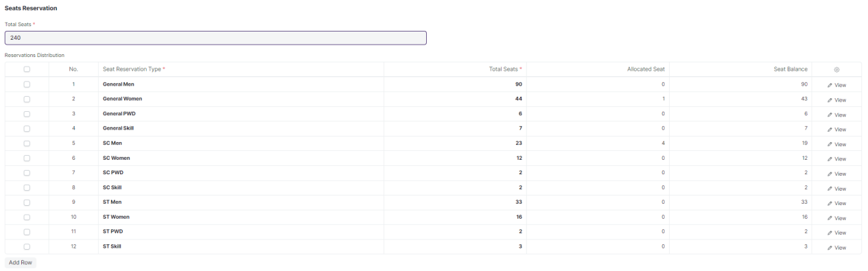

1. Enter Seats Reservation

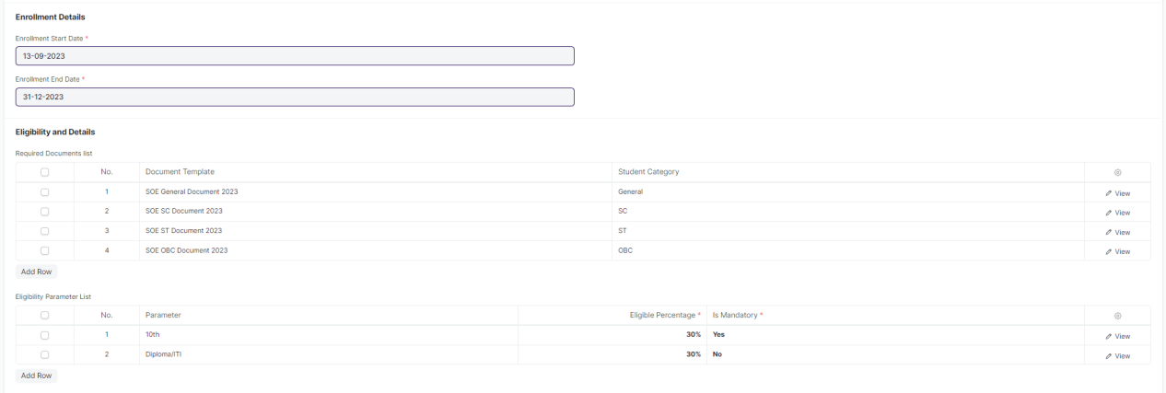

1. Enter Enrollment Details and Eligibility Details
2. Select Admission fee are applicable or not
3. Click on Save.

## Student Applicant

A Student Applicant record gets created when a student applies to your institute for admission.

You can Approve or Reject a student applicant. By accepting a student applicant, you can add them to the student master.

To access Student Applicant, go to:

**Home > Admission > Student Enrollment> Student Applicant**

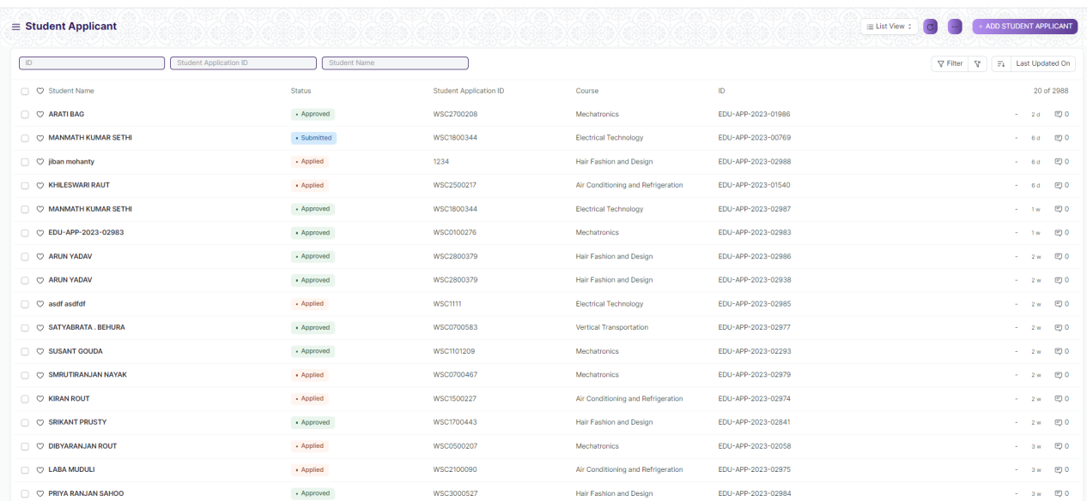

#### Prerequisites

Before creating a Student Applicant, it is advised to create:

1. Caste Category
2. Academic Year
3. Academic Term
4. Student Category
5. Department
6. Course Type
7. Course
8. Gender
9. Religion
10. State
11. District
12. Block

#### How to creates a Student Applicant

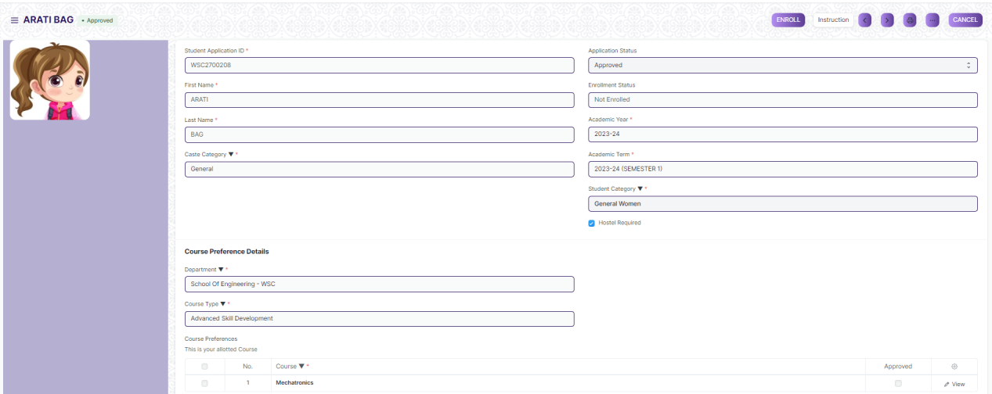

1. Go to the student Applicant and click on New.

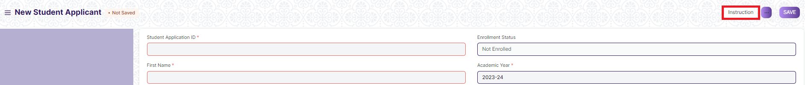

1. User can see Instruction through button.
2. Enter Student Application ID, First Name and Last Name

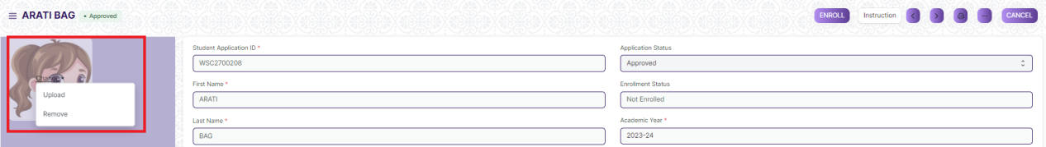

1. Upload Image
2. Enter the Student Email Address.
3. Select Caste Category, Student Category, Academic Year and Academic Term
4. Enter the Personal Details, Home Address and Guardian Details.
5. Click on Save.

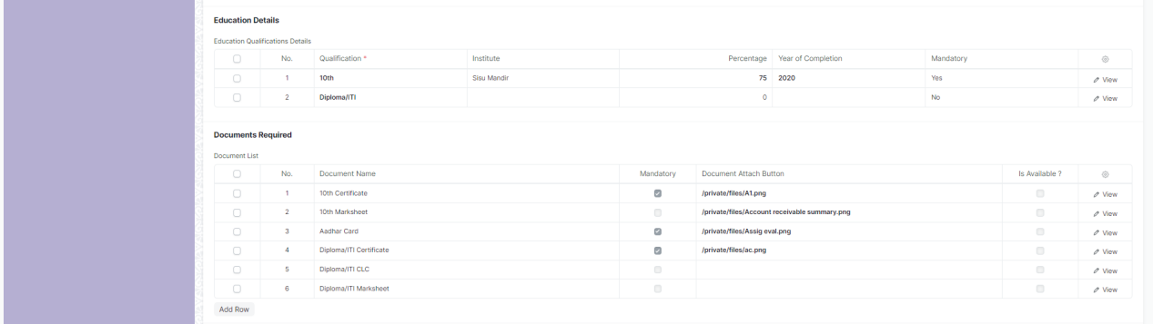

1. After Save, Education Detail and Document Required will fetch and then student will enter education detail.

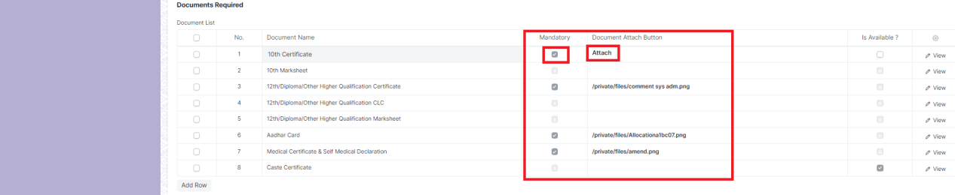

1. Student will upload document those are mandatory



1. Click on Preview button to see filled data.
2. Click on Submit



1. After Submit, Trainer can able to Approve the student.

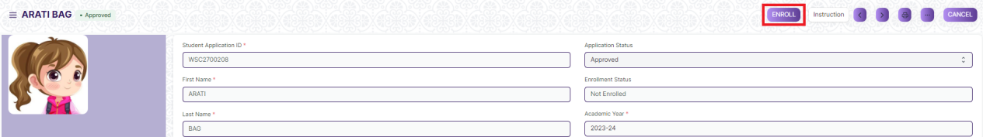

1. After approved Enroll button will visible through that button Trainer can create Course Enrollment for that particular student

## Course Enrollment

Course Enrollment is the record of enrollment of a student in a given course and chosen courses for a particular Academic Term.

To ensure that students are associated with a particular course in the system, their Course Enrollment must be created. The mandatory module in that course is automatically filled in the Enrolled module table while the elective or optional module can be selected manually.

If the student has applied online for the admission in a particular course

and the application is approved, then the Course Enrollment can be created from within the Student Applicant record via clicking on the Enroll button. Checkout Student Applicant for more information on this.

To access Course Enrollment, go to:

**Home > Admission > Student Enrollment > Course Enrollment**

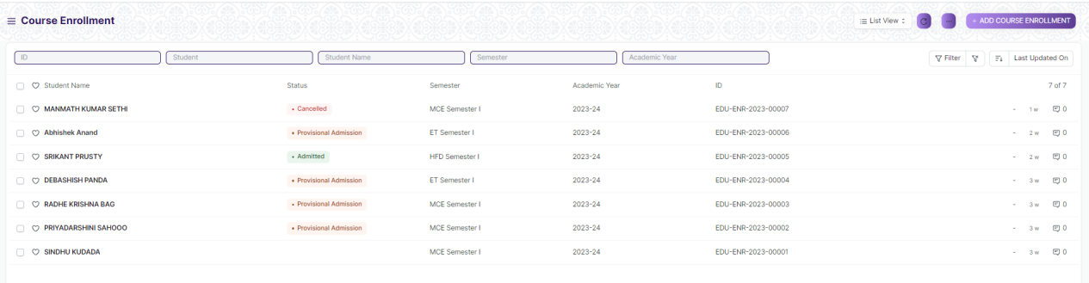

#### Prerequisites

Before creating a Course Enrollment, it is advised to create:

1. Student or Student Applicant
2. Course
3. Semester
4. Academic Year
5. Academic Term
6. Fee Category (If Fees is Applicable)
7. Fee Structure(If Fees is Applicable)

#### How to creates a Course Enrollment

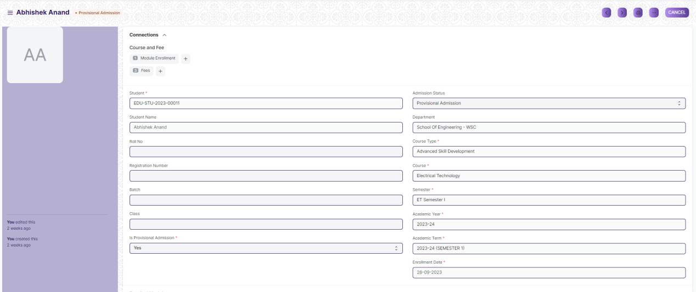

1. Go to Course Enrollment List and click on new.
2. Select the Student whom you are getting enrolled in the Course.
3. Select the Course under which you are getting the student enrolled.
4. Enter the Academic Year for which the student is getting enrolled.
5. Enter Class, Gender, Batch, Cast Category and etc.
6. The Enrollment Date for the form would by default be set on the current date, the same, however, can be changed if needed.
7. Select Admission Status as “Provisional Admission” or Admitted
8. Select “Is Provisional Admission” as Yes or No.



**Note**: Select Yes when Admission status is “Provisional Admission” or select No.

1. Click on Save.
2. Enter Due Date if Fees is Applicable
3. Click On Submit

## Module Enrollment

Module Enrollment is the record of enrollment of a student in a given course and chosen module for a particular Academic Term.

To ensure that students are associated with a particular course in the system, their Module Enrollment must be created/auto-generated. The mandatory module in that course is automatically filled in the Enrolled Courses table while the elective or optional modules can be selected manually.

If the student has applied online for the admission in a particular course and the application is approved, then the module Enrollment is auto-created from within the Course Enrollment record.

To access Module Enrollment, go to:

**Home > Admission > Student Enrollment > Module Enrollment**

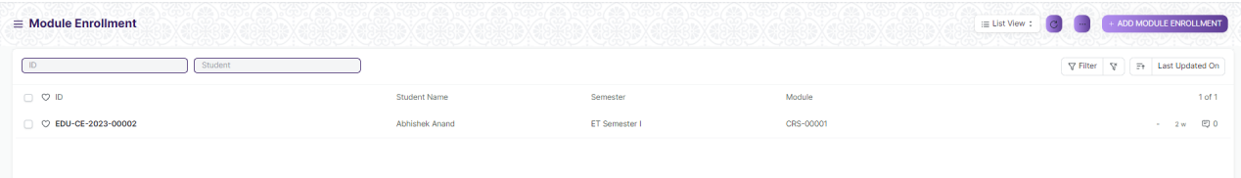

#### Prerequisites

Before creating a Module Enrollment, it is advised to create:

1. Course Enrollment
2. Module
3. Student
4. Course
5. Department
6. Semester
7. Academic Year
8. Academic Term

#### How to creates a Module Enrollment

1. Go to Module Enrollment List and click on new.

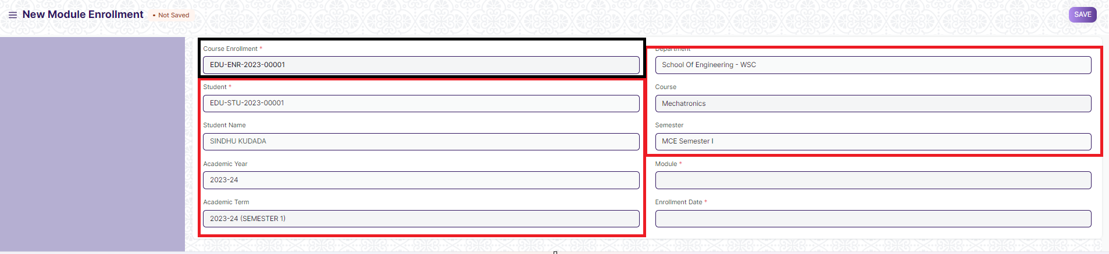

1. Select the Course Enrollment after that all data will fetch

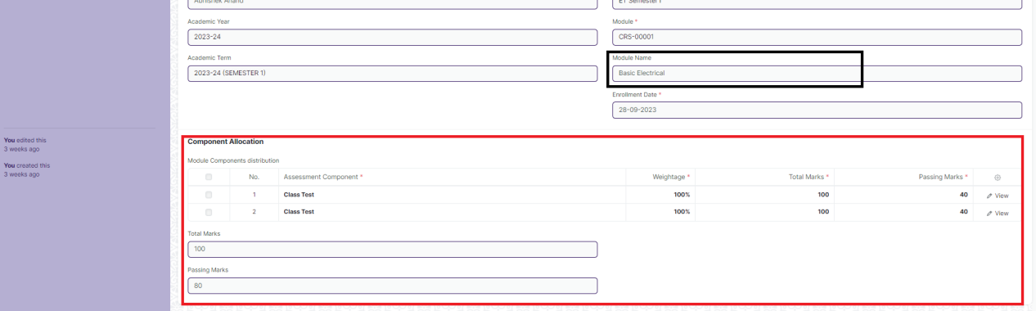

1. Select Module after that all module linked data will fetch
2. Click on Save

## Fee Structure

A Fee Structure is a template that can be used while making Fees records or generating them via the Fee Schedule.

The Fee structure can be fetched while creating the [Fees](https://docs.erpnext.com/docs/v13/user/manual/en/education/fees) for each student.

To access Fee Structure, go to:

**Home > Admission > Fees > Fee Structure**

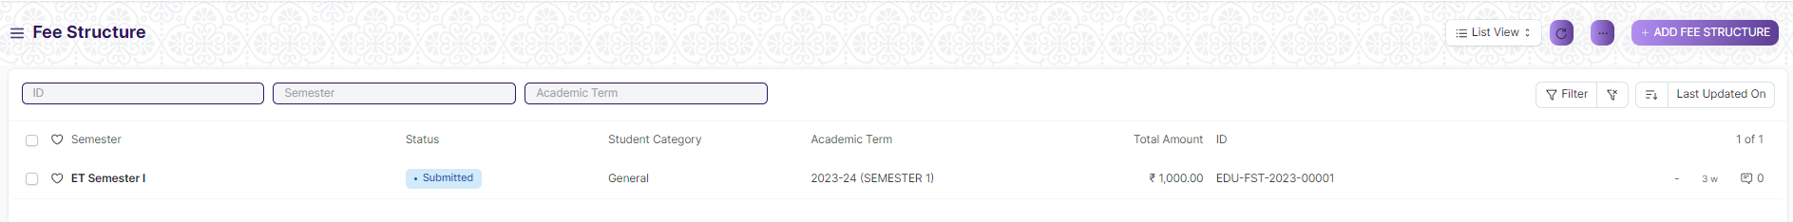

#### Prerequisites

Before creating a Fee Structure, it is advised to create:

1. Course Type
2. Course
3. Semester
4. Student Category
5. Fee Type
6. Academic Year
7. Academic Term
8. Fee Category
9. Account
10. Company
11. Cost Center

#### How to creates a Fee Structure

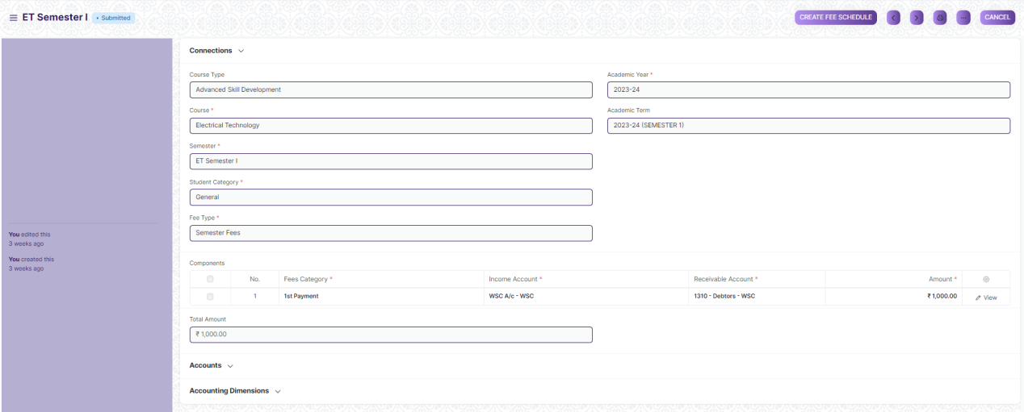

1. Go to Fee Structure List and click on new.
2. Select Course Type, Course, Semester, Student Category, Fee Type, Academic Year and Academic Term.
3. Add Fee Category and Amount in the Components table.
4. Click on Save and Submit.

## Fee Schedule

Fee Schedule would help you in defining a time-line for the Fee payment of the students, based on the Student Group.

To access Fee Schedule, go to:

**Home > Admission > Fees > Fee Schedule**

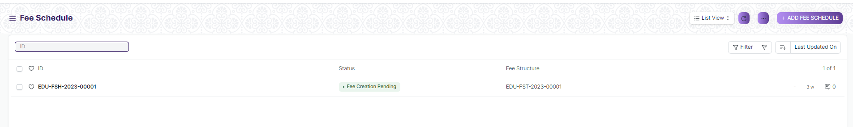

#### Prerequisites

Before creating a Fee Structure, it is advised to create:

1. Fee Structure
2. Student Group

#### How to creates a Fee Schedule

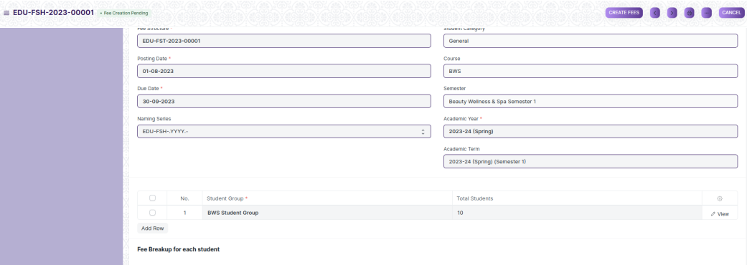

1. Go to Fee Schedule List and click on new.
2. Select Fee Structure and all related data will fetch on field.
3. Add Due date.
4. Select Student Group
5. Click on Save and Submit.



Note: You can create fees for student group through “Create fees” button.

## Fee Category

Fee Category would form all the components for calculation of Fees or creation of Fee Structure.

For example, Tuition Fees and Hostel fees would make the different categories of fees.

To access Fee Schedule, go to:

**Home > Admission > Fees > Fee Category**

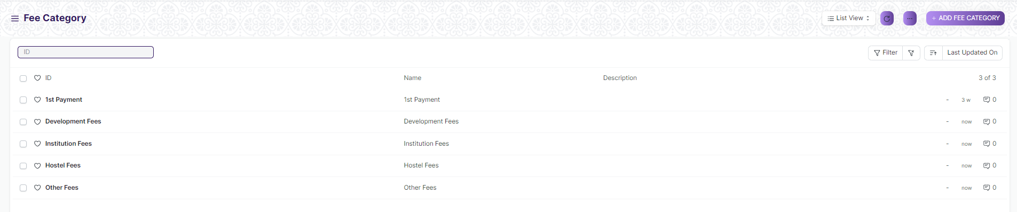

#### How to creates a Fee Category

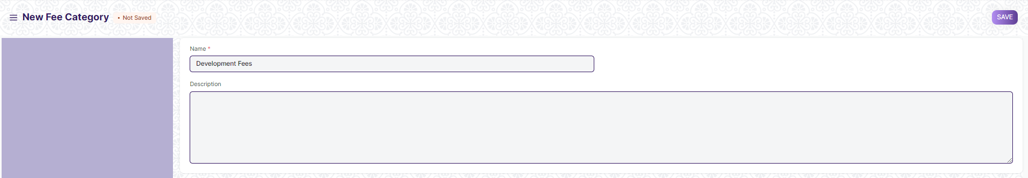

1. Go to Fee Category List and click on new.
2. Enter Name.
3. Click on Save

## Fees

By Creating Fees, we can maintain the Fee Records of the students.

At the time of submission of Fees by each student, a new Fees Record will be created where in all the details of the student, Course they are enrolled in, Accounting information, etc. would be maintained.

To access Fees, go to:

**Home > Admission > Fees > Fees**

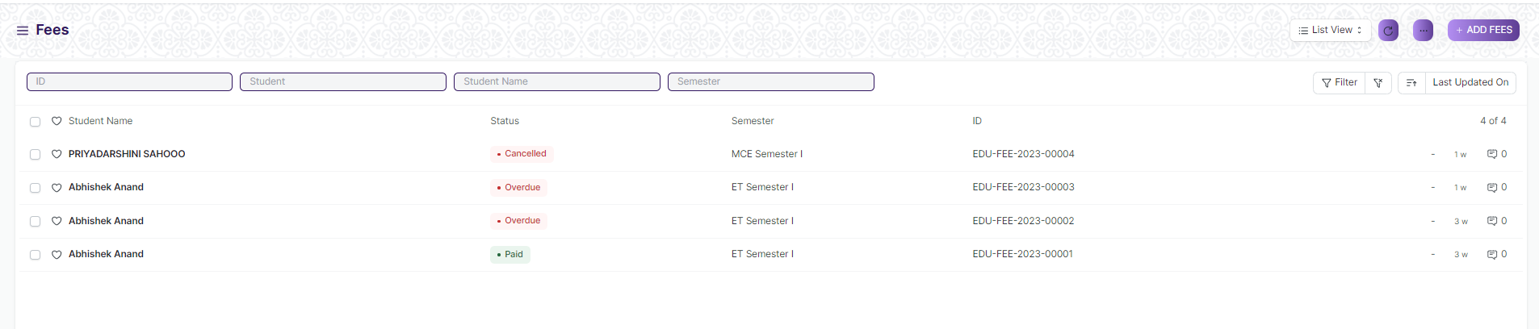

#### Prerequisites

Before creating a Fees, it is advised to create:

1. Fee Structure
2. Student
3. Fee Category

#### How to creates a Fees

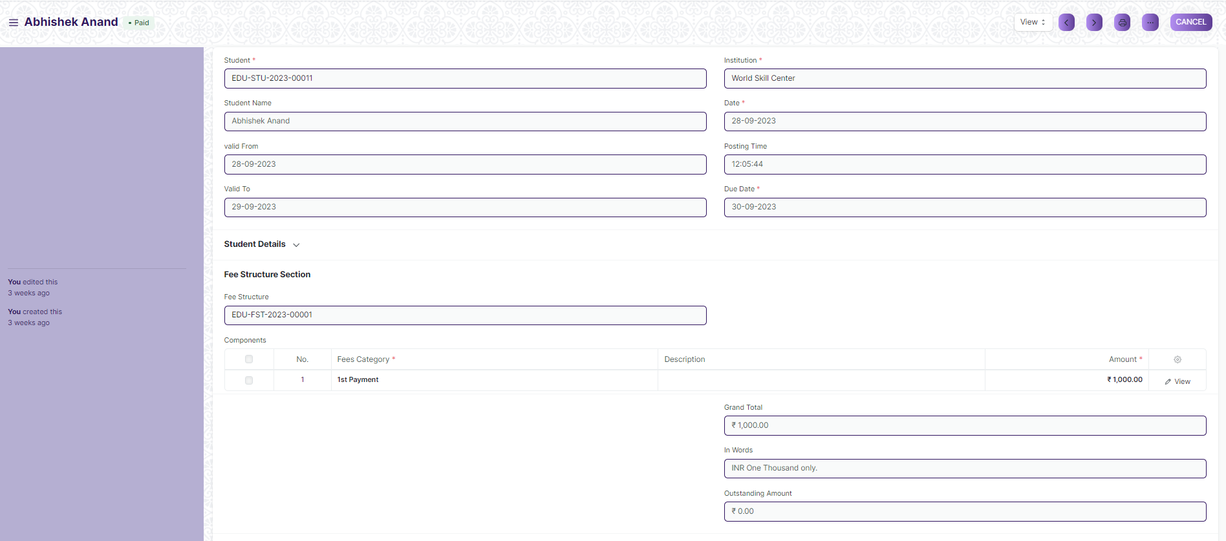

1. Go to Fee Category List and click on new.
2. Select Student, Due Date, Valid from, Valid to.

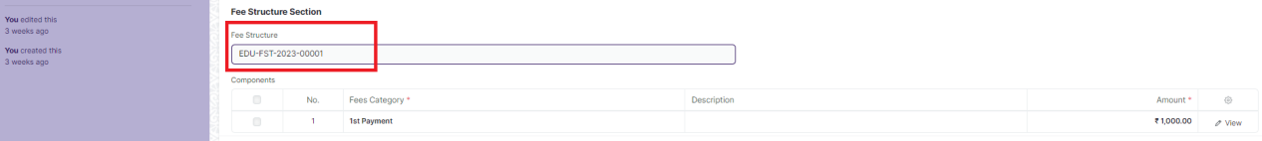

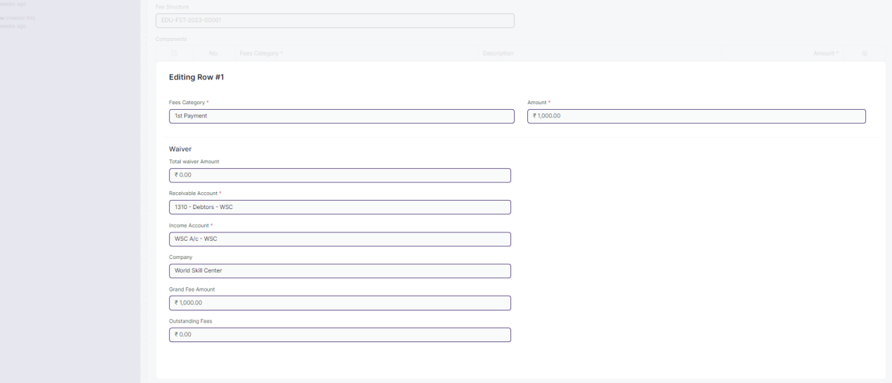

1. Select Fee Structure and all related data will fetch on table
2. Add Receivable Account on table.
3. Click on Save and Submit.

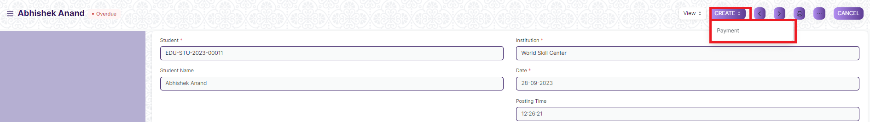



1. After Submitting, the Payment button will become visible, and when the payment is completed, the status on the fees will show as “Paid”



1. When Payment is not made, the status shows as “Unpaid”



1. When Payment is not made by the due date, the status shows as “Overdue”

## Auto Reconciliation

Auto reconciliation is a process in financial and accounting systems that automates the matching and verification of financial transactions to ensure accuracy and consistency.

To access Auto Reconciliation, go to:

**Home > Admission > Fees > Auto Reconciliation**

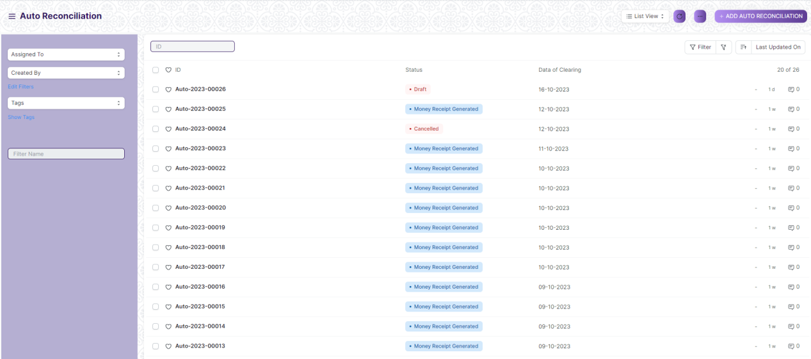

#### Prerequisites

Before creating a Auto Reconciliation, it is advised to create:

1. Student
2. Online Payment

#### How to creates a Auto Reconciliation

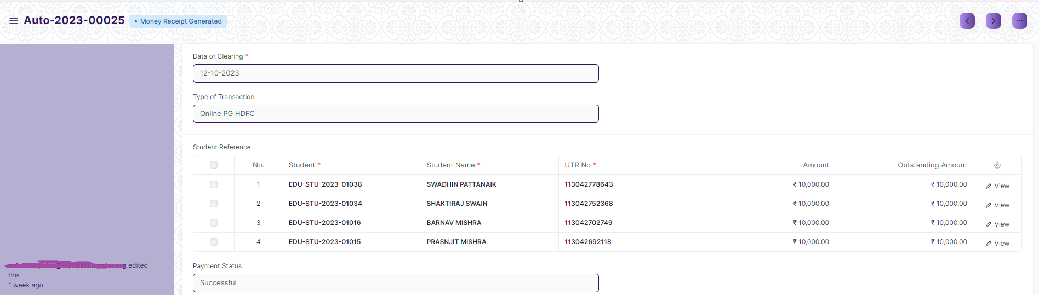

1. Go to Auto Reconciliation List and click on new.
2. Enter Date of Clearing
3. Select Type of Transaction as “Online PG HDFC” or “Online PG AXIS”

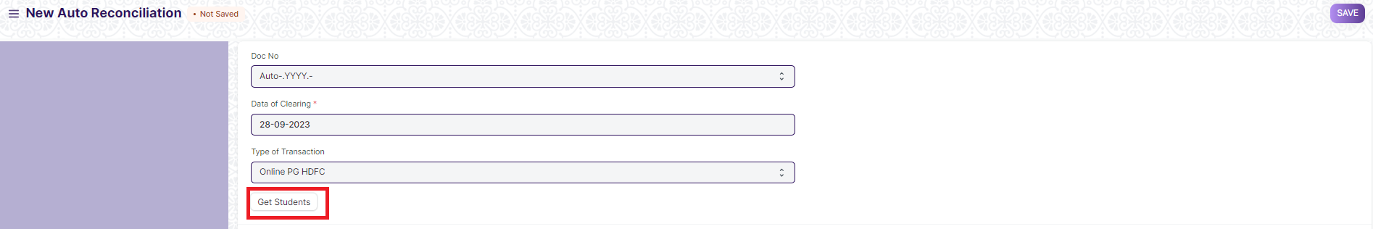

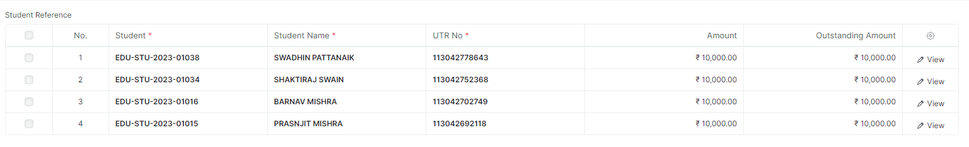

1. Click on Student button then data will fetch on Student Reference table
2. Click on Save and Submit.



1. Payment Status will show accordingly.

## Online Payment

Online payment, also known as digital payment, refers to the process of transferring money or making financial transactions by user.

To access Online Payment, go to:

**Home > Admission > Fees > Online Payment**

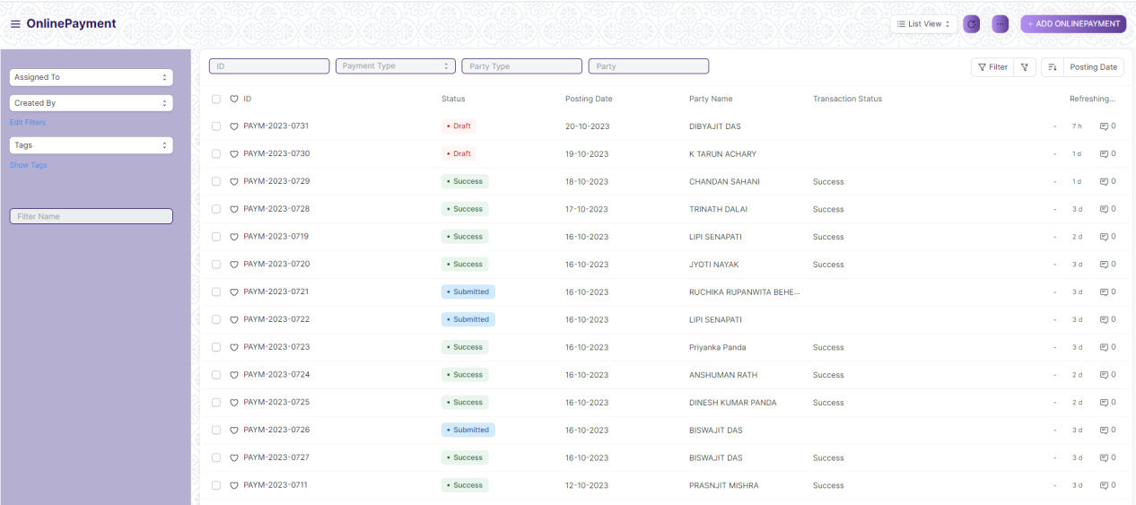

#### Prerequisites

Before creating a Auto Reconciliation, it is advised to create:

1. Student
2. Course Enrollment

#### How to creates a Online Payment

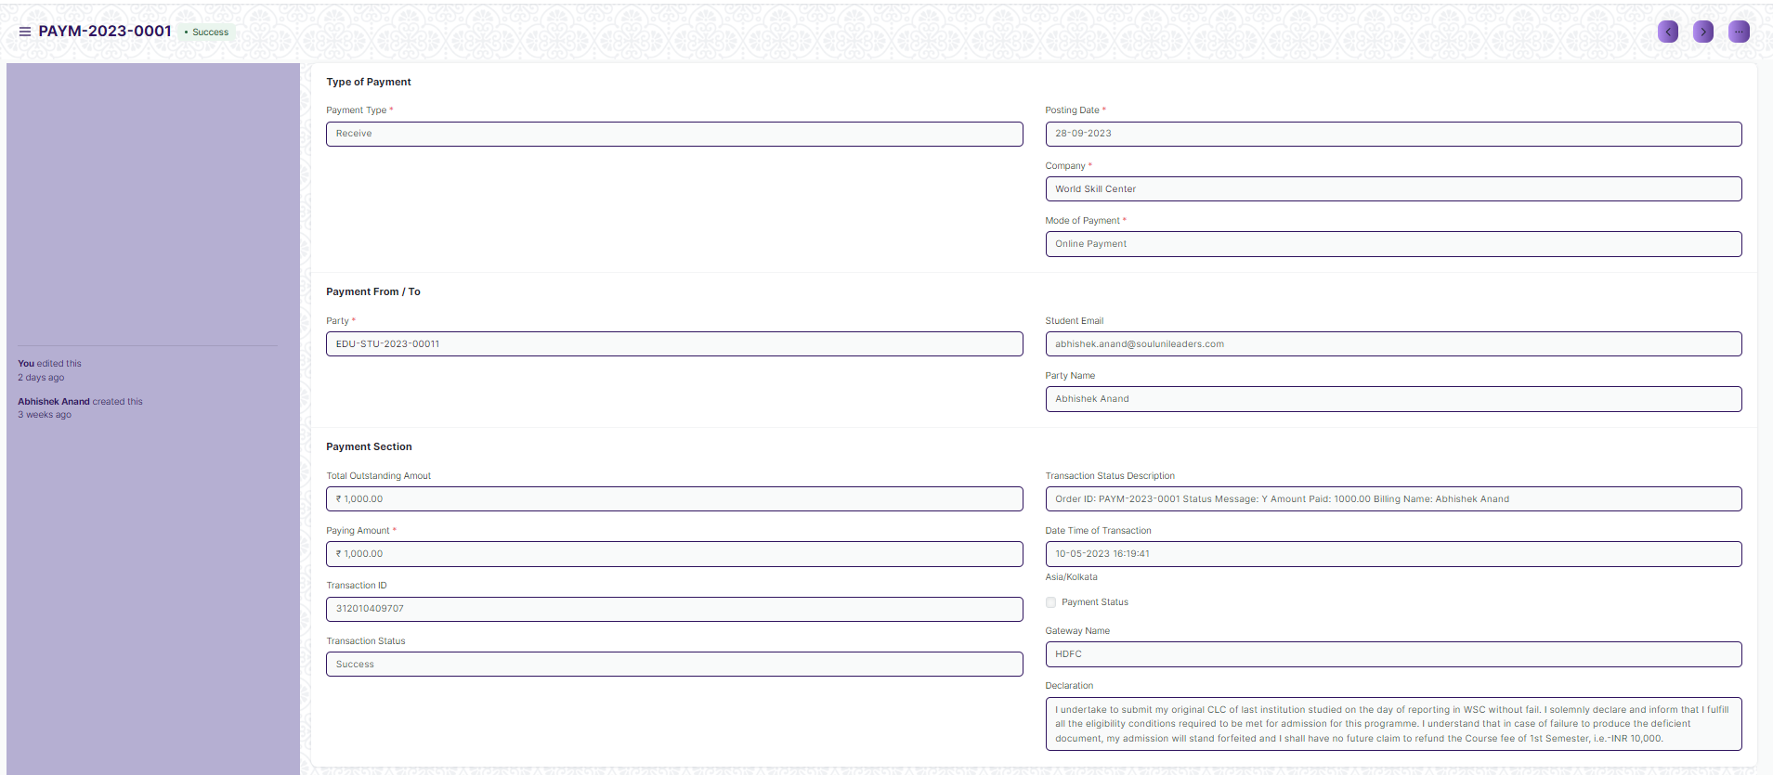

1. Go to Online Payment List and click on new.
2. Student Detail will auto fetch.
3. Only Paying Amount needs to enter. And then click on save button.



1. Click on Online Payment button and select By HDFC Payment Gateway

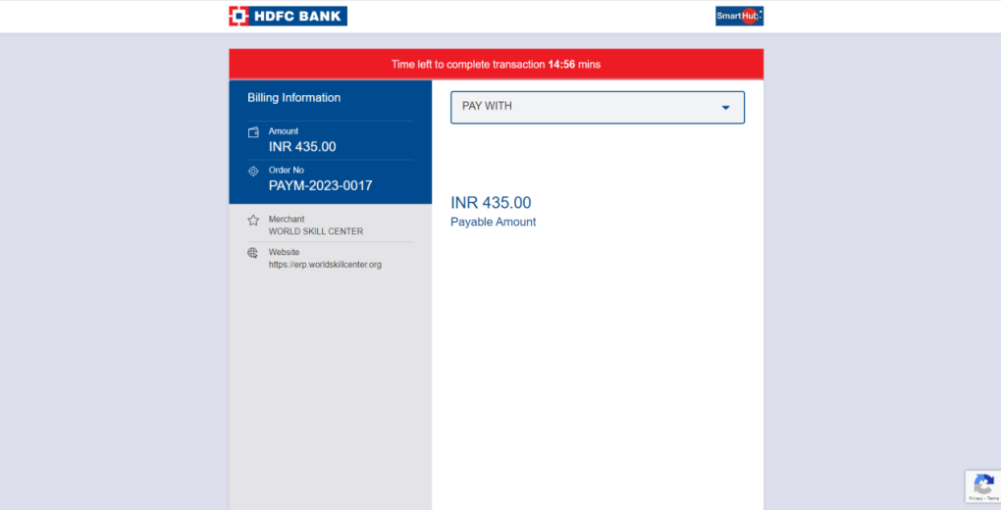

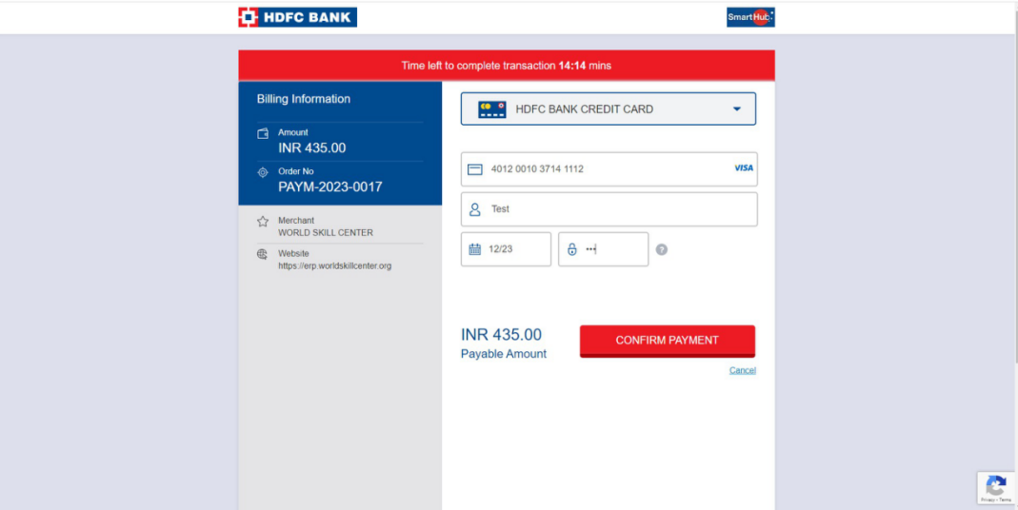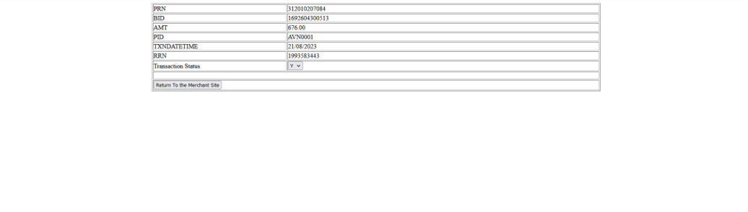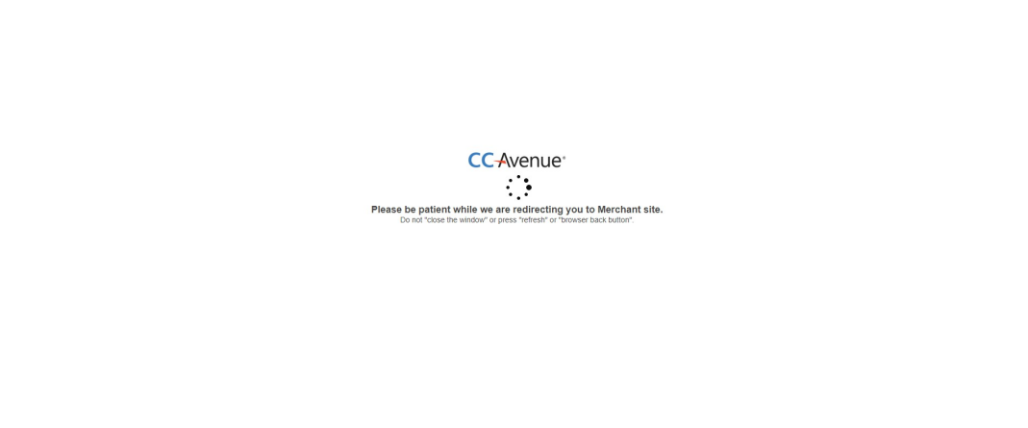

1. It will open payment gateway

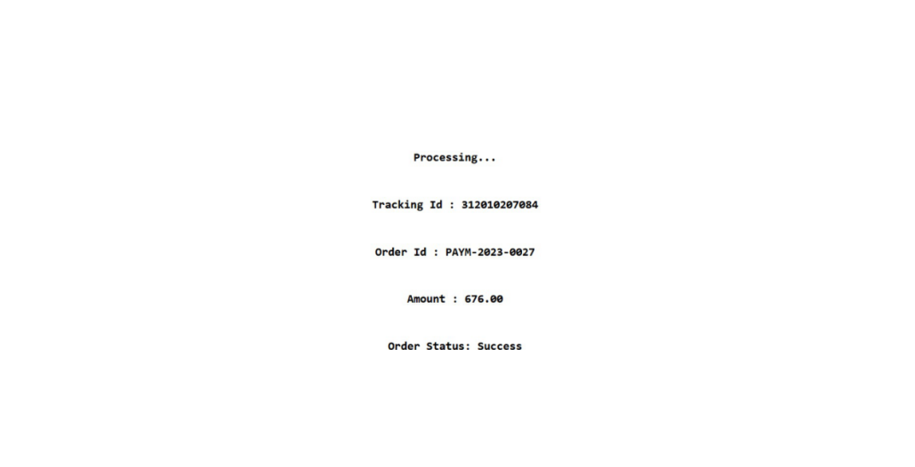

1. It show response page after transaction

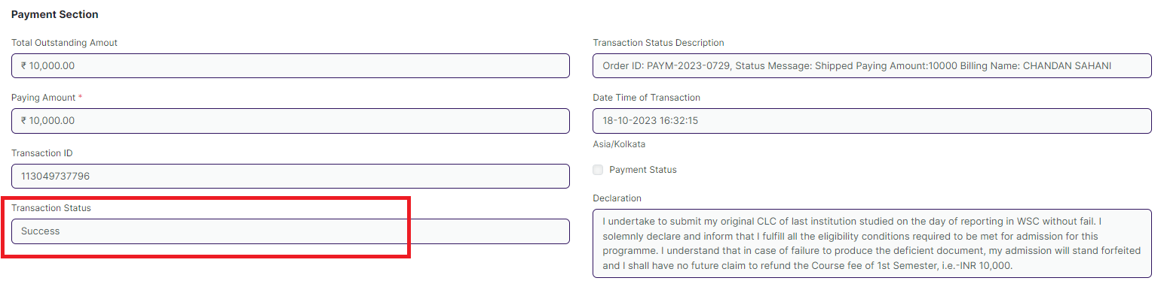

1. User can see Transaction response data in transaction status field

## Course Enrollment Tool

Course Enrollment tool is a tool for Re-enroll the students once they have completed the examination and there is a need to promote the entire group of students to the next class.

To access Course Enrollment Tool, go to:

**Home > Admission > Tools> Course Enrollment Tool**

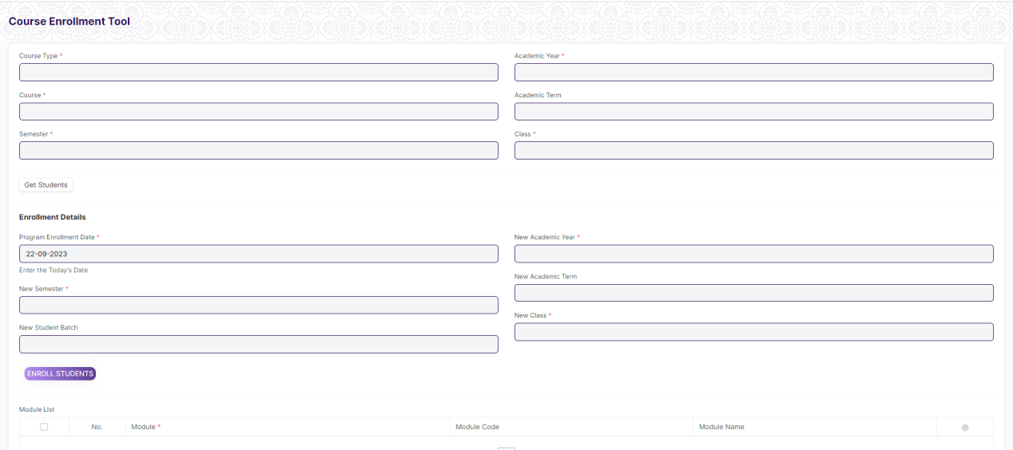

#### Prerequisites

Before creating a Course Enrollment Tool, it is advised to create:

1. Student
2. Course Type
3. Course
4. Semester
5. Academic Year
6. Academic Term
7. Class

#### How to creates a Course Enrollment Tool

1. Open Course Enrollment Tool.
2. Select Course Type, Course, Semester, Academic Year, Academic Term and Class.

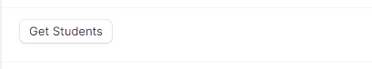

1. Click on the Get Student button and all the students for that course will be fetched in the table.
2. Select Additional module if required.
3. Select and enter New Semester, New Student Batch, New Academic Year, New Academic Term and New Class.
4. The mandatory module for the next semester will be auto fetched.

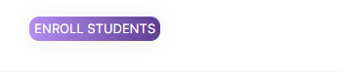

1. Click on “Enroll Students” button.

## Student Feedback Form

Student Feedback Form gives you an opportunity to convey your response towards your trainer who taught you in your classes.

To access Student Feedback Form, go to:

**Home > Admission > Feedback > Student Feedback Form**

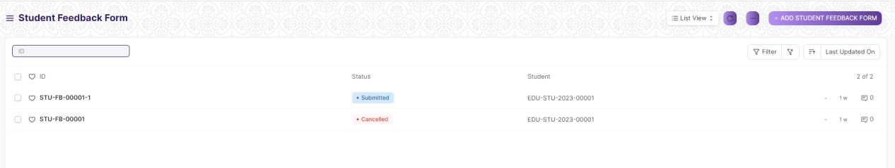

#### Prerequisites

Before creating a Student Feedback Form, it is advised to create:

1. Student
2. Module
3. Trainer

#### How to creates a Student Feedback Form

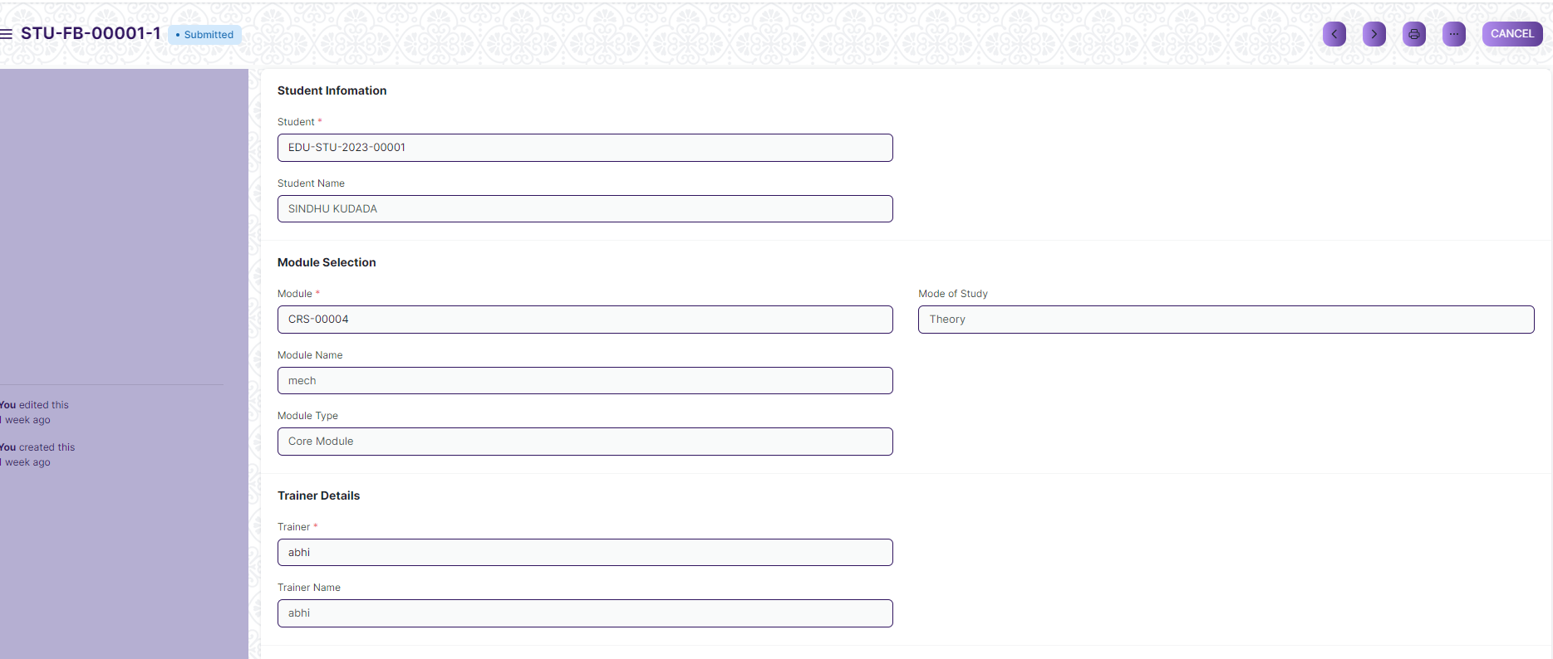

1. Go to Student Feedback Form list and click on new.
2. Select Student, Module and Trainer then question will fetch on table.

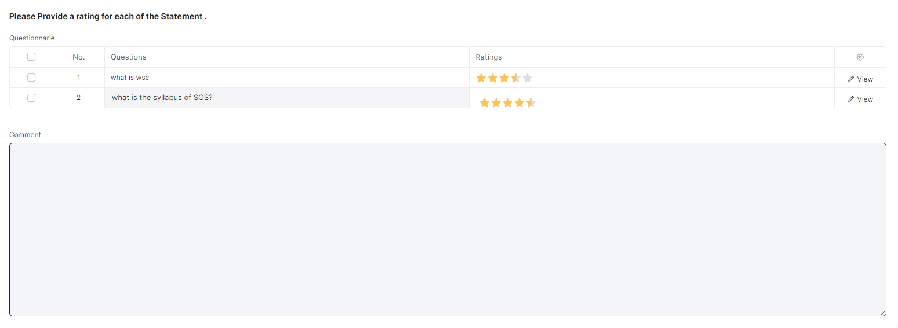

1. Student will give rating
2. Student will give comment
3. Click on Save and Submit